**习水医院RAC12C重建**

目录

0、磁盘空间分配 4

1、数据库集群Oracle RAC规划及实施 5

1.1、RAC拓扑 5

1.2、网络规划 5

1.3、存储规划 6

1.4、数据库安装环境配置 6

1.5、安装Grid Infrastructure 45

1.5.1、解压安装文件 45

1.5.2、安装GRID 45

1.5.3、指定安装和配置GridCluster 47

1.5.4、选择产品语言，添加简体中文 48

1.6.1、 配置SCAN 49

1.6.2、 配置节点IP与ssh测试 51

1.6.3、 选择网卡 52

1.6.4、 选择Shared File System 53

1.6.5、 选择Ocr File Location 54

1.6.6、 选择Create ASM Disk Group 55

1.6.7、 配置ASM 管理密码 56

1.6.9、选择默认 57

1.6.10、 选择操作系统组数 58

1.6.11、选择ORACLE_BASE和ORACLE_HOME 59

1.6.12、 操作系统环境检测 61

1.6.13、 安装程序汇总 62

1.6.14、 开始安装 63

1.6.15、按照提示在主机上运行orainstRoot.sh和root.sh 64

1.6.16、 安装完成 73

2、 安装完成后检查状态 74

3、 解压软件 83

4.7、安装ORACLE12c数据库软件 83

4.7.2、运行安装命令 83

4.7.1 配置安装选项，选择install database software only 85

4.7.2 配置grid安装选项，选择oracle RAC install database 86

4.7.3 选择所有节点，setup SSH，并test SSH 87

4.7.4 选择安装语言 88

4.7.5 选择企业版安装 89

4.7.6 选择安装路径 90

4.7.7 默认指定相关组 91

4.7.8 安装检查 92

4.7.9 安装程序汇总 93

4.7.10 开始安装 94

4.7.11 安装完成后，主机运行root.sh文件 94

1.1.2. 节点ORACLE1 95

1.1.3. 节点ORACLE2 96

4.7.12 安装完成 97

4.8、 创建ORACLE12c数据库实例 97

4.8.1 选择Create Database 99

4.8.2 选择高级模式 100

4.8.3 选择数据库、配置类型和数据模版 101

4.8.4 输入全域数据库名称和sid前缀 102

4.8.5 选择集群节点 103

4.8.6 配置em 104

4.8.7 设置数据库密码 105

4.8.8 选择数据文件保存位置 106

4.8.9 配置数据库参数 108

4.8.10 数据库创建选项 112

4.8.11 建库检查 113

4.8.12 建库信息概要 115

4.8.13 开始建库 116

4.8.14 建库完成 117

4.8.15 Password Management 118

4.9、 查看资源组情况 118

## 0、磁盘空间分配

|  |  |  |  |  |
| --- | --- | --- | --- | --- |
| **空间名称** | **磁盘阵列模式** | **空间大小** | **磁盘类型** | **使用对象** |
| His-crs1 | Raid6 | 10G | SATA | Crs组 |
| His-crs2 | Raid6 | 10G | SATA |
| His-crs3 | Raid6 | 10G | SATA |
| His-data1 | Raid6 | 1T | SATA | Data组 |
| His-data2 | Raid6 | 1T | SATA |
| His-data3 | Raid6 | 1T | SATA |
| His-databak | Raid6 | 500G | SATA | Flash组 |
| His-flash | Raid6 | 500G | SATA |

## 1、数据库集群Oracle RAC规划及实施

### 1.1、RAC拓扑



### 1.2、网络规划

|  |  |  |  |
| --- | --- | --- | --- |
| **接口** | **Node1** | **Node2** | **Host** |
| 公网 | 172.16.28.40 | 172.16.28.40 | oracle1、oracle1 |
| 私网 | 10.10.10.40 | 10.10.10.41 | oracle1pri、oracle1pri |
| vimp | 172.16.28.42 | 172.16.28.43 | oracle1vip、oracle1vip |
| scan | 172.16.28.44 | | scanip |

### 1.3、存储规划

|  |  |  |  |  |  |
| --- | --- | --- | --- | --- | --- |
| **存储组件** | **文件系统** | **卷大小** | **卷组名** | **冗余** | **备注** |
| CRS | ASM | 10G | +CRS | 正常 | 3块 |
| DATA | ASM | 1T | +DATA | 正常 | 3块 |
| Flash | ASM | 500G | +FLASH |  | 2块 |

### 1.4、数据库安装环境配置

#### 1.4.1、操作系统

|  |
| --- |
| [root@oracle1 ~]# uname -a  Linux oracle1.com 2.6.32-431.el6.x86_64 #1 SMP Sun Nov 10 22:19:54 EST 2013 x86_64 x86_64 x86_64 GNU/Linux |
| [root@oracle2 ~]# uname -a  Linux oracle2.com 2.6.32-431.el6.x86_64 #1 SMP Sun Nov 10 22:19:54 EST 2013 x86_64 x86_64 x86_64 GNU/Linux |

#### 1.4.2、安装依赖包

安装Oracle RAC必须的依赖包，命令如下：

|  |
| --- |
| yum -y install binutils compat-libstdc++-33 elfutils-libelf \  elfutils-libelf-devel elfutils-libelf-devel-static gcc gcc-c++ glibc glibc-common \  glibc-devel kernel-headers ksh libaio libaio-devel libgcc libgomp libstdc++ libstdc++-devel \  make numactl-devel sysstat unixODBC unixODBC-devel pdksh compat-libcap1 |

##### 1.4.2.1、节点ORACLE1

|  |
| --- |
| [root@oracle1 ~]# yum -y install binutils compat-libstdc++-33 elfutils-libelf \  > elfutils-libelf-devel elfutils-libelf-devel-static gcc gcc-c++ glibc glibc-common \  > glibc-devel kernel-headers ksh libaio libaio-devel libgcc libgomp libstdc++ libstdc++-devel \  > make numactl-devel sysstat unixODBC unixODBC-devel pdksh compat-libcap1  已加载插件：fastestmirror, langpacks  base | 3.6 kB 00:00  extras | 3.4 kB 00:00  updates | 3.4 kB 00:00  extras/7/x86_64/primary_db | 117 kB 00:00  Loading mirror speeds from cached hostfile  * base: mirrors.163.com  * extras: mirrors.163.com  * updates: mirrors.cqu.edu.cn  软件包 compat-libstdc++-33-3.2.3-72.el7.x86_64 已安装并且是最新版本  软件包 gcc-4.8.5-4.el7.x86_64 已安装并且是最新版本  软件包 gcc-c++-4.8.5-4.el7.x86_64 已安装并且是最新版本  软件包 ksh-20120801-22.el7_1.3.x86_64 已安装并且是最新版本  软件包 libaio-0.3.109-13.el7.x86_64 已安装并且是最新版本  软件包 libaio-devel-0.3.109-13.el7.x86_64 已安装并且是最新版本  软件包 libgcc-4.8.5-4.el7.x86_64 已安装并且是最新版本  软件包 libgomp-4.8.5-4.el7.x86_64 已安装并且是最新版本  软件包 libstdc++-4.8.5-4.el7.x86_64 已安装并且是最新版本  软件包 libstdc++-devel-4.8.5-4.el7.x86_64 已安装并且是最新版本  软件包 1:make-3.82-21.el7.x86_64 已安装并且是最新版本  软件包 sysstat-10.1.5-7.el7.x86_64 已安装并且是最新版本  没有可用软件包 pdksh。  软件包 compat-libcap1-1.10-7.el7.x86_64 已安装并且是最新版本  正在解决依赖关系  --> 正在检查事务  ---> 软件包 binutils.x86_64.0.2.23.52.0.1-30.el7 将被 升级  ---> 软件包 binutils.x86_64.0.2.23.52.0.1-55.el7 将被 更新  ---> 软件包 elfutils-libelf.x86_64.0.0.160-1.el7 将被 升级  --> 正在处理依赖关系 elfutils-libelf(x86-64) = 0.160-1.el7，它被软件包 elfutils-libs-0.160-1.el7.x86_64 需要  --> 正在处理依赖关系 elfutils-libelf(x86-64) = 0.160-1.el7，它被软件包 elfutils-0.160-1.el7.x86_64 需要  ---> 软件包 elfutils-libelf.x86_64.0.0.163-3.el7 将被 更新  ---> 软件包 elfutils-libelf-devel.x86_64.0.0.163-3.el7 将被 安装  ---> 软件包 elfutils-libelf-devel-static.x86_64.0.0.163-3.el7 将被 安装  ---> 软件包 glibc.x86_64.0.2.17-78.el7 将被 升级  --> 正在处理依赖关系 glibc = 2.17-78.el7，它被软件包 glibc-headers-2.17-78.el7.x86_64 需要  ---> 软件包 glibc.x86_64.0.2.17-106.el7_2.4 将被 更新  ---> 软件包 glibc-common.x86_64.0.2.17-78.el7 将被 升级  ---> 软件包 glibc-common.x86_64.0.2.17-106.el7_2.4 将被 更新  ---> 软件包 glibc-devel.x86_64.0.2.17-78.el7 将被 升级  ---> 软件包 glibc-devel.x86_64.0.2.17-106.el7_2.4 将被 更新  ---> 软件包 kernel-headers.x86_64.0.3.10.0-229.el7 将被 升级  ---> 软件包 kernel-headers.x86_64.0.3.10.0-327.13.1.el7 将被 更新  ---> 软件包 numactl-devel.x86_64.0.2.0.9-6.el7_2 将被 安装  --> 正在处理依赖关系 numactl-libs = 2.0.9-6.el7_2，它被软件包 numactl-devel-2.0.9-6.el7_2.x86_64 需要  ---> 软件包 unixODBC.x86_64.0.2.3.1-11.el7 将被 安装  ---> 软件包 unixODBC-devel.x86_64.0.2.3.1-11.el7 将被 安装  --> 正在检查事务  ---> 软件包 elfutils.x86_64.0.0.160-1.el7 将被 升级  ---> 软件包 elfutils.x86_64.0.0.163-3.el7 将被 更新  ---> 软件包 elfutils-libs.x86_64.0.0.160-1.el7 将被 升级  ---> 软件包 elfutils-libs.x86_64.0.0.163-3.el7 将被 更新  ---> 软件包 glibc-headers.x86_64.0.2.17-78.el7 将被 升级  ---> 软件包 glibc-headers.x86_64.0.2.17-106.el7_2.4 将被 更新  ---> 软件包 numactl-libs.x86_64.0.2.0.9-4.el7 将被 升级  ---> 软件包 numactl-libs.x86_64.0.2.0.9-6.el7_2 将被 更新  --> 解决依赖关系完成  依赖关系解决  ================================================================================  Package 架构 版本 源 大小  ================================================================================  正在安装:  elfutils-libelf-devel x86_64 0.163-3.el7 base 35 k  elfutils-libelf-devel-static x86_64 0.163-3.el7 base 69 k  numactl-devel x86_64 2.0.9-6.el7_2 updates 23 k  unixODBC x86_64 2.3.1-11.el7 base 413 k  unixODBC-devel x86_64 2.3.1-11.el7 base 55 k  正在更新:  binutils x86_64 2.23.52.0.1-55.el7 base 5.0 M  elfutils-libelf x86_64 0.163-3.el7 base 200 k  glibc x86_64 2.17-106.el7_2.4 updates 3.6 M  glibc-common x86_64 2.17-106.el7_2.4 updates 11 M  glibc-devel x86_64 2.17-106.el7_2.4 updates 1.0 M  kernel-headers x86_64 3.10.0-327.13.1.el7 updates 3.2 M  为依赖而更新:  elfutils x86_64 0.163-3.el7 base 268 k  elfutils-libs x86_64 0.163-3.el7 base 260 k  glibc-headers x86_64 2.17-106.el7_2.4 updates 662 k  numactl-libs x86_64 2.0.9-6.el7_2 updates 29 k  事务概要  ================================================================================  安装 5 软件包  升级 6 软件包 (+4 依赖软件包)  总计：26 M  总下载量：594 k  Downloading packages:  (1/5): numactl-devel-2.0.9-6.el7_2.x86_64.rpm | 23 kB 00:00  (2/5): elfutils-libelf-devel-0.163-3.el7.x86_64.rpm | 35 kB 00:00  (3/5): unixODBC-devel-2.3.1-11.el7.x86_64.rpm | 55 kB 00:00  (4/5): elfutils-libelf-devel-static-0.163-3.el7.x86_64.rpm | 69 kB 00:00  (5/5): unixODBC-2.3.1-11.el7.x86_64.rpm | 413 kB 00:02  --------------------------------------------------------------------------------  总计 234 kB/s | 594 kB 00:02  Running transaction check  Running transaction test  Transaction test succeeded  Running transaction  正在更新 : glibc-2.17-106.el7_2.4.x86_64 1/25  正在更新 : glibc-common-2.17-106.el7_2.4.x86_64 2/25  正在更新 : elfutils-libelf-0.163-3.el7.x86_64 3/25  正在更新 : elfutils-libs-0.163-3.el7.x86_64 4/25  正在安装 : elfutils-libelf-devel-0.163-3.el7.x86_64 5/25  正在安装 : unixODBC-2.3.1-11.el7.x86_64 6/25  正在更新 : numactl-libs-2.0.9-6.el7_2.x86_64 7/25  正在更新 : kernel-headers-3.10.0-327.13.1.el7.x86_64 8/25  正在更新 : glibc-headers-2.17-106.el7_2.4.x86_64 9/25  正在更新 : glibc-devel-2.17-106.el7_2.4.x86_64 10/25  正在安装 : numactl-devel-2.0.9-6.el7_2.x86_64 11/25  正在安装 : unixODBC-devel-2.3.1-11.el7.x86_64 12/25  正在安装 : elfutils-libelf-devel-static-0.163-3.el7.x86_64 13/25  正在更新 : elfutils-0.163-3.el7.x86_64 14/25  正在更新 : binutils-2.23.52.0.1-55.el7.x86_64 15/25  清理 : elfutils-0.160-1.el7.x86_64 16/25  清理 : glibc-devel-2.17-78.el7.x86_64 17/25  清理 : elfutils-libs-0.160-1.el7.x86_64 18/25  清理 : glibc-headers-2.17-78.el7.x86_64 19/25  清理 : elfutils-libelf-0.160-1.el7.x86_64 20/25  清理 : binutils-2.23.52.0.1-30.el7.x86_64 21/25  清理 : numactl-libs-2.0.9-4.el7.x86_64 22/25  清理 : kernel-headers-3.10.0-229.el7.x86_64 23/25  清理 : glibc-common-2.17-78.el7.x86_64 24/25  清理 : glibc-2.17-78.el7.x86_64 25/25  验证中 : elfutils-libs-0.163-3.el7.x86_64 1/25  验证中 : glibc-common-2.17-106.el7_2.4.x86_64 2/25  验证中 : elfutils-0.163-3.el7.x86_64 3/25  验证中 : elfutils-libelf-0.163-3.el7.x86_64 4/25  验证中 : glibc-devel-2.17-106.el7_2.4.x86_64 5/25  验证中 : kernel-headers-3.10.0-327.13.1.el7.x86_64 6/25  验证中 : numactl-devel-2.0.9-6.el7_2.x86_64 7/25  验证中 : unixODBC-2.3.1-11.el7.x86_64 8/25  验证中 : glibc-headers-2.17-106.el7_2.4.x86_64 9/25  验证中 : numactl-libs-2.0.9-6.el7_2.x86_64 10/25  验证中 : elfutils-libelf-devel-static-0.163-3.el7.x86_64 11/25  验证中 : binutils-2.23.52.0.1-55.el7.x86_64 12/25  验证中 : elfutils-libelf-devel-0.163-3.el7.x86_64 13/25  验证中 : unixODBC-devel-2.3.1-11.el7.x86_64 14/25  验证中 : glibc-2.17-106.el7_2.4.x86_64 15/25  验证中 : glibc-2.17-78.el7.x86_64 16/25  验证中 : elfutils-libs-0.160-1.el7.x86_64 17/25  验证中 : elfutils-libelf-0.160-1.el7.x86_64 18/25  验证中 : elfutils-0.160-1.el7.x86_64 19/25  验证中 : glibc-devel-2.17-78.el7.x86_64 20/25  验证中 : kernel-headers-3.10.0-229.el7.x86_64 21/25  验证中 : glibc-headers-2.17-78.el7.x86_64 22/25  验证中 : glibc-common-2.17-78.el7.x86_64 23/25  验证中 : binutils-2.23.52.0.1-30.el7.x86_64 24/25  验证中 : numactl-libs-2.0.9-4.el7.x86_64 25/25  已安装:  elfutils-libelf-devel.x86_64 0:0.163-3.el7  elfutils-libelf-devel-static.x86_64 0:0.163-3.el7  numactl-devel.x86_64 0:2.0.9-6.el7_2  unixODBC.x86_64 0:2.3.1-11.el7  unixODBC-devel.x86_64 0:2.3.1-11.el7  更新完毕:  binutils.x86_64 0:2.23.52.0.1-55.el7  elfutils-libelf.x86_64 0:0.163-3.el7  glibc.x86_64 0:2.17-106.el7_2.4  glibc-common.x86_64 0:2.17-106.el7_2.4  glibc-devel.x86_64 0:2.17-106.el7_2.4  kernel-headers.x86_64 0:3.10.0-327.13.1.el7  作为依赖被升级:  elfutils.x86_64 0:0.163-3.el7 elfutils-libs.x86_64 0:0.163-3.el7  glibc-headers.x86_64 0:2.17-106.el7_2.4 numactl-libs.x86_64 0:2.0.9-6.el7_2  完毕！  [root@oracle1 ~]# |

##### 1.4.2.2、节点ORACLE2

|  |
| --- |
| [root@oracle2 ~]# yum -y install binutils compat-libstdc++-33 elfutils-libelf \  > elfutils-libelf-devel elfutils-libelf-devel-static gcc gcc-c++ glibc glibc-common \  > glibc-devel kernel-headers ksh libaio libaio-devel libgcc libgomp libstdc++ libstdc++-devel \  > make numactl-devel sysstat unixODBC unixODBC-devel pdksh compat-libcap1  已加载插件：langpacks  软件包 binutils-2.23.52.0.1-55.el7.x86_64 已安装并且是最新版本  软件包 compat-libstdc++-33-3.2.3-72.el7.x86_64 已安装并且是最新版本  软件包 elfutils-libelf-0.163-3.el7.x86_64 已安装并且是最新版本  软件包 elfutils-libelf-devel-0.163-3.el7.x86_64 已安装并且是最新版本  软件包 elfutils-libelf-devel-static-0.163-3.el7.x86_64 已安装并且是最新版本  软件包 gcc-4.8.5-4.el7.x86_64 已安装并且是最新版本  软件包 gcc-c++-4.8.5-4.el7.x86_64 已安装并且是最新版本  软件包 glibc-2.17-106.el7_2.4.x86_64 已安装并且是最新版本  软件包 glibc-common-2.17-106.el7_2.4.x86_64 已安装并且是最新版本  软件包 glibc-devel-2.17-106.el7_2.4.x86_64 已安装并且是最新版本  软件包 kernel-headers-3.10.0-327.13.1.el7.x86_64 已安装并且是最新版本  软件包 ksh-20120801-22.el7_1.3.x86_64 已安装并且是最新版本  软件包 libaio-0.3.109-13.el7.x86_64 已安装并且是最新版本  软件包 libaio-devel-0.3.109-13.el7.x86_64 已安装并且是最新版本  软件包 libgcc-4.8.5-4.el7.x86_64 已安装并且是最新版本  软件包 libgomp-4.8.5-4.el7.x86_64 已安装并且是最新版本  软件包 libstdc++-4.8.5-4.el7.x86_64 已安装并且是最新版本  软件包 libstdc++-devel-4.8.5-4.el7.x86_64 已安装并且是最新版本  软件包 1:make-3.82-21.el7.x86_64 已安装并且是最新版本  软件包 numactl-devel-2.0.9-6.el7_2.x86_64 已安装并且是最新版本  软件包 sysstat-10.1.5-7.el7.x86_64 已安装并且是最新版本  软件包 unixODBC-2.3.1-11.el7.x86_64 已安装并且是最新版本  软件包 unixODBC-devel-2.3.1-11.el7.x86_64 已安装并且是最新版本  没有可用软件包 pdksh。  软件包 compat-libcap1-1.10-7.el7.x86_64 已安装并且是最新版本  无须任何处理  [root@oracle2 ~]# |

#### 1.4.2.3、没有可用软件包

yum库不可用的软件包pdksh，可在Oracle的安装软件中

|  |
| --- |
| [root@oracle1]# rpm -ivh pdksh-5.2.14-37.el5_8.1.x86_64.rpm  警告：pdksh-5.2.14-37.el5_8.1.x86_64.rpm: 头V3 DSA/SHA1 Signature, 密钥 ID e8562897: NOKEY  错误：依赖检测失败：  pdksh 与 (已安裝) ksh-20120801-22.el7_1.3.x86_64 冲突  [root@oracle1 12c]# rpm -e ksh  [root@oracle1 12c]# rpm -ivh pdksh-5.2.14-37.el5_8.1.x86_64.rpm  警告：pdksh-5.2.14-37.el5_8.1.x86_64.rpm: 头V3 DSA/SHA1 Signature, 密钥 ID e8562897: NOKEY  准备中... ################################# [100%]  正在升级/安装...  1:pdksh-5.2.14-37.el5_8.1 ################################# [100%]  [root@oracle1]# |

#### 1.4.3Hosts、文件配置

|  |
| --- |
| [root@oracle1 ~]# cat /etc/hosts  127.0.0.1 localhost localhost.localdomain localhost4 localhost4.localdomain4  ::1 localhost localhost.localdomain localhost6 localhost6.localdomain6  #public IP  172.16.28.40 oracle1 oracle1.com  172.16.28.41 oracle2 oracle2.com  #private IP  10.10.10.40 oracle1pri  10.10.10.41 oracle2pri  #virtual IP  172.16.28.42 oracle1vip  172.16.28.43 oracle2vip  #scanip  172.16.28.44 scanip |
| [root@oracle2 ~]# cat /etc/hosts  127.0.0.1 localhost localhost.localdomain localhost4 localhost4.localdomain4  ::1 localhost localhost.localdomain localhost6 localhost6.localdomain6  #public IP  172.16.28.40 oracle1 oracle1.com  172.16.28.41 oracle2 oracle2.com  #private IP  10.10.10.40 oracle1pri  10.10.10.41 oracle2pri  #virtual IP  172.16.28.42 oracle1vip  172.16.28.43 oracle2vip  #scanip   * + - 1. canip |

#### 1.4.4、添加组与用户

|  |
| --- |
|  |

|  |
| --- |
| [root@oracle1 ~]# passwd grid  更改用户 grid 的密码 。  新的 密码：  无效的密码： 密码少于 8 个字符  重新输入新的 密码：  passwd：所有的身份验证令牌已经成功更新。  [root@oracle1 ~]# passwd oracle  更改用户 oracle 的密码 。  新的 密码：  无效的密码： 密码少于 8 个字符  重新输入新的 密码：  passwd：所有的身份验证令牌已经成功更新。  [root@oracle1 ~]# |

#### 1.4.5、添加文件系统

|  |
| --- |
| mkdir -p /oracle/app/grid  mkdir -p /oracle/app/12.1/grid  chown -R grid:oinstall /oracle  mkdir -p /oracle/app/oraInventory  chown -R grid:oinstall /oracle/app/oraInventory  mkdir -p /oracle/app/oracle  chown -R oracle:oinstall /oracle/app/oracle  chmod -R 775 /oracle |

##### 1.4.5.1、节点ORACLE1

|  |
| --- |
| [root@oracle1 ~]# mkdir -p /oracle/app/grid  [root@oracle1 ~]# mkdir -p /oracle/app/12.1/grid  [root@oracle1 ~]# chown -R grid:oinstall /oracle  [root@oracle1 ~]#mkdir -p /oracle/app/oraInventory  [root@oracle1 ~]# chown -R grid:oinstall /oracle/app/oraInventory  [root@oracle1 ~]# mkdir -p /oracle/app/oracle  [root@oracle1 ~]# chown -R oracle:oinstall /oracle/app/oracle  [root@oracle1 ~]# chmod -R 775 /oracle  [root@oracle1 ~]# df -h  [root@oracle1 ~]# df -h  Filesystem Size Used Avail Use% Mounted on  /dev/mapper/VolGroup-lv_root 50G 23G 25G 49% /  tmpfs 2.0G 753M 1.3G 37% /dev/shm  /dev/sdk1 485M 40M 420M 9% /boot  /dev/mapper/VolGroup-lv_home 496G 5.9G 465G 2% /home  [root@oracle1 ~]# id grid  uid=54321(grid) gid=54321(oinstall) groups=54321(oinstall),54322(dba),54327(asmdba),54328(asmoper),54329(asmadmin)  [root@oracle1 ~]# id oracle  uid=54322(oracle) gid=54321(oinstall) groups=54321(oinstall),54322(dba),54323(oper),54324(backupdba),54325(dgdba),54326(kmdba),54327(asmdba),54329(asmadmin)  [root@oracle1 ~]# |

##### 1.4.5.2、节点ORACLE2

|  |
| --- |
| [root@oracle2 ~]# mkdir -p /oracle/app/grid  [root@oracle2 ~]# mkdir -p /oracle/app/12.1/grid  [root@oracle2 ~]# chown -R grid:oinstall /oracle  [root@oracle2 ~]# mkdir -p /oracle/app/oraInventory  [root@oracle2 ~]# chown -R grid:oinstall /oracle/app/oraInventory  [root@oracle2 ~]# mkdir -p /oracle/app/oracle  [root@oracle2 ~]# chown -R oracle:oinstall /oracle/app/oracle  [root@oracle2 ~]# chmod -R 775 /oracle  [root@oracle2 ~]# df -h  Filesystem Size Used Avail Use% Mounted on  /dev/mapper/VolGroup-lv_root 50G 20G 28G 42% /  tmpfs 2.0G 753M 1.3G 37% /dev/shm  /dev/sdk1 485M 40M 420M 9% /boot  /dev/mapper/VolGroup-lv_home 496G 5.4G 465G 2% /home  [root@oracle1 ~]# id grid  uid=54321(grid) gid=54321(oinstall) groups=54321(oinstall),54322(dba),54327(asmdba),54328(asmoper),54329(asmadmin)  [root@oracle1 ~]# id oracle  uid=54322(oracle) gid=54321(oinstall) groups=54321(oinstall),54322(dba),54323(oper),54324(backupdba),54325(dgdba),54326(kmdba),54327(asmdba),54329(asmadmin)  [root@oracle1 ~]# |

#### 1.4.6、修改操作系统参数

##### 1.4.6.1、limits.conf

vimm /etc/security/limits.conf

添加内容如下：

|  |
| --- |
| [root@oracle1 ~]# vimm /etc/security/limits.conf  #Oracle setting  grid soft nofile 1024  grid hard nofile 65536  grid soft nproc 2047  grid hard nproc 16384  grid soft stack 10240  grid hard stack 32768  oracle soft nofile 1024  oracle hard nofile 65536  oracle soft nproc 2047  oracle hard nproc 16384  oracle soft stack 10240  oracle hard stack 32768  oracle hard memlock 118536840 |

##### 1.4.6.2、90-nproc.conf

vimm /etc/security/limits.d/90-nproc.conf

添加内容如下：

|  |
| --- |
| #Oracle setting  * - nproc 16384 |

##### 1.4.6.3、SELINUX

vimm /etc/selinux/config

修改内容如下：

|  |
| --- |
| [root@oracle1 ~]# cat /etc/selinux/config  # This file controls the state of SELinux on the system.  # SELINUX= can take one of these three values:  # enforcing - SELinux security policy is enforced.  # permissive - SELinux prints warnings instead of enforcing.  # disabled - No SELinux policy is loaded.  #SELINUX=enforcing  SELINUX=disabled  # SELINUXTYPE= can take one of three two values:  # targeted - Targeted processes are protected,  # minimum - Modification of targeted policy. Only selected processes are protected.  # mls - Multi Level Security protection.  SELINUXTYPE=targeted  [root@oracle1 ~]# setenforce 0  setenforce: SELinux is disabled  [root@oracle1 ~]# |

##### 1.4.6.4、Iptables

关闭iptables：

|  |
| --- |
| [root@oracle1 ~]#servimce iptables stop  [root@oracle1 ~]#chkconfig --level 345 iptables off  [root@oracle1 ~]#chkconfig --level 345 ip6tables off |

##### 1.4.6.5、Login

vimm /etc/pam.d/login

添加内容如下：

|  |
| --- |
| [root@oracle1 ~]# vimm /etc/pam.d/login  #oracle setting  session required pam_limits.so  [root@oracle1 ~]# |

##### 1.4.6.6、sysctl.conf

vimm /etc/sysctl.conf

修改内容如下：

|  |
| --- |
| [root@oracle1 ~]# vimm /etc/sysctl.conf  fs.aio-max-nr = 1048576  fs.file-max = 6815744  kernel.sem = 250 32000 100 128  kernel.shmmni = 4096  kernel.shmall = 1073741824  kernel.shmmax = 4398046511104  net.core.rmem_default = 262144  net.core.rmem_max = 4194304  net.core.wmem_default = 262144  net.core.wmem_max = 1048576  net.ipv4.ip_local_port_range = 9000 65500  [root@oracle1 ~]# sysctl -p  fs.aio-max-nr = 1048576  fs.file-max = 6815744  kernel.sem = 250 32000 100 128  kernel.shmmni = 4096  kernel.shmall = 1073741824  kernel.shmmax = 4398046511104  net.core.rmem_default = 262144  net.core.rmem_max = 4194304  net.core.wmem_default = 262144  net.core.wmem_max = 1048576  net.ipv4.ip_local_port_range = 9000 65500  [root@oracle1 ~]# |

##### 1.4.6.7、profile

vimm /etc/profile

添加内容如下：

|  |
| --- |
| [root@oracle1 ~]# vim /etc/profile  if [ $USER = "oracle" ] || [ $USER = "grid" ]; then  if [ $SHELL = "/bin/ksh" ]; then  ulimit -p 16384  ulimit -n 65536  else  ulimit -u 16384 -n 65536  fi  umask 022  fi |

##### 1.4.6.8、修改shm

vimm /etc/fstab

修改内容如下

|  |
| --- |
| [root@oracle1 ~]# vim /etc/fstab  tmpfs /dev/shm tmpfs defaults,size=2048M 0 0  [root@oracle1 ~]# mount /dev/shm |

#### 1.1.7、禁止NTP

|  |
| --- |
| [root@oracle1]# servimce ntpd stop  Redirecting to /bin/systemctl stop ntpd.servimce  Failed to issue method call: Unit ntpd.servimce not loaded.  [root@oracle1]# chkconfig ntpd off  [root@oracle1 ntp]# |

#### 配置grid 和 oracle 用户的环境变量

##### 1.4.8.1、节点ORACLE1

|  |
| --- |
| [grid@oracle1 ~]$vim .bash_profile  [grid@oracle1 ~]# cat /home/grid/.bash_profile  # .bash_profile  #grid setting  export TMP=/tmp  export TMPDIR=$TMP  export ORACLE_HOSTNAME=oracle1.com  export ORACLE_BASE=/oracle/app/grid  export ORACLE_HOME=/oracle/app/12.1/grid  export ORACLE_SID=+ASM1  export PATH=/usr/sbin:$PATH  export PATH=$ORACLE_HOME/bin:$PATH  export LD_LIBRARY_PATH=$ORACLE_HOME/lib:/lib:/usr/lib  export CLASSPATH=$ORACLE_HOME/JRE:$ORACLE_HOME/jlib:$ORACLE_HOME/rdbms/jlib |
| [oracle@oracle1 ~]$ cat /home/oracle/.bash_profile  # .bash_profile  # oracle setting  export PATH  export TMP=/tmp  export TMPDIR=$TMP  export ORACLE_HOSTNAME=oracle1.com  export ORACLE_UNQNAME=oracle1  export ORACLE_BASE=/oracle/app/oracle  export ORACLE_HOME=$ORACLE_BASE/product/12.1.0/dbhome_1  #export ORACLE_SID=oracle  #export ORACLE_SID=orcl  #export ORACLE_SID=orcl  export PATH=/usr/sbin:$PATH  export PATH=$ORACLE_HOME/bin:$PATH  export LD_LIBRARY_PATH=$ORACLE_HOME/lib:/lib:/usr/lib  export CLASSPATH=$ORACLE_HOME/JRE:$ORACLE_HOME/jlib:$ORACLE_HOME/rdbms/jlib |

##### 1.4.8.2、节点ORACLE2

|  |
| --- |
| [grid@oracle2 ~]$ cat /home/grid/.bash_profile  # .bash_profile  #grid setting  export TMP=/tmp  export TMPDIR=$TMP  export ORACLE_HOSTNAME=oracle2.com  export ORACLE_BASE=/oracle/app/grid  export ORACLE_HOME=/oracle/app/12.1/grid  export ORACLE_SID=+ASM2  export PATH=/usr/sbin:$PATH  export PATH=$ORACLE_HOME/bin:$PATH  export LD_LIBRARY_PATH=$ORACLE_HOME/lib:/lib:/usr/lib  export CLASSPATH=$ORACLE_HOME/JRE:$ORACLE_HOME/jlib:$ORACLE_HOME/rdbms/jlib |
| [oracle@oracle2 ~]$ cat /home/oracle/.bash_profile  # .bash_profile  # oracle setting  export PATH  export TMP=/tmp  export TMPDIR=$TMP  export ORACLE_HOSTNAME=oracle2.com  export ORACLE_UNQNAME=oracle2  export ORACLE_BASE=/oracle/app/oracle/  export ORACLE_HOME=$ORACLE_BASE/product/12.1.0/dbhome_1  #export ORACLE_SID=oracle2  #export ORACLE_SID=orcl  #export ORACLE_SID=orcl  export PATH=/usr/sbin:$PATH  export PATH=$ORACLE_HOME/bin:$PATH  export LD_LIBRARY_PATH=$ORACLE_HOME/lib:/lib:/usr/lib  export CLASSPATH=$ORACLE_HOME/JRE:$ORACLE_HOME/jlib:$ORACLE_HOME/rdbms/jlib  #alias sqlplus="rlwrap sqlplus"  #alias rman="rlwrap rman" |

#### 配置ssh信任关系

##### 1.4.9.1、创建ssh证书

#ORACLE1、ORACLE2上oracle和grid用户执行，命令如下：

|  |
| --- |
| [root@oracle1 ~]# su grid  [grid@oracle1 ~]$mkdir ~/.ssh && cd /home/grid  [grid@oracle1 ~]$ls -a  [grid@oracle1 ~]$ssh-keygen -t rsa  [grid@oracle1 ~]$ssh-keygen -t dsa  [root@oracle1 ~]# su oracle  [oracle@oracle1 ~]$ mkdir ~/.ssh && cd /home/oracle  [oracle@oracle1 ~]$ls -a  [oracle@oracle1 ~]$ssh-keygen -t rsa  [oracle@oracle1 ~]$ssh-keygen -t dsa |

###### 1.4.9.1.1、节点ORACLE1

|  |
| --- |
| 切换grid用户：  [root@oracle1 ~]# su - grid  [grid@oracle1 ~]$mkdir ~/.ssh  [grid@oracle1 ~]$cd /home/grid/  [grid@oracle1 ~]$ls -a  . .. .bash_history .bash_profile .cache .config grid.rsp .ssh .vimminfo  [grid@oracle1 ~]$ssh-keygen -t rsa  Generating public/private rsa key pair.  Enter file in which to save the key (/home/grid/.ssh/id_rsa):  /home/grid/.ssh/id_rsa already exists.  Overwrite (y/n)? y  Enter passphrase (empty for no passphrase):  Enter same passphrase again:  Your identification has been saved in /home/grid/.ssh/id_rsa.  Your public key has been saved in /home/grid/.ssh/id_rsa.pub.  The key fingerprint is:  ef:41:ef:07:ae:33:5b:9f:16:dc:61:9a:7a:21:d5:8f grid@oracle1  The key's randomart image is:  +--[ RSA 2048]----+  | |  | |  | . |  | . + |  | S . ..+oo|  | o o.+E o|  | o.=... |  | .o=.oo. |  | +=ooo |  +-----------------+  [grid@oracle1 ~]$ssh-keygen -t dsa  Generating public/private dsa key pair.  Enter file in which to save the key (/home/grid/.ssh/id_dsa):  Enter passphrase (empty for no passphrase):  Enter same passphrase again:  Your identification has been saved in /home/grid/.ssh/id_dsa.  Your public key has been saved in /home/grid/.ssh/id_dsa.pub.  The key fingerprint is:  af:35:87:7e:04:f5:e6:b2:44:5d:bc:34:f4:66:7c:ae grid@oracle1  The key's randomart image is:  +--[ DSA 1024]----+  | .o |  | . ++|  | . o..O|  | . . +=.|  | S o o .|  | . .+ .. |  | =o.oE |  | + oo |  | . .. |  +-----------------+  [grid@oracle1 ~]$exit  切换oracle用户：  [root@oracle1 ~]# su - oracle  [oracle@oracle1 ~]$mkdir ~/.ssh  [oracle@oracle1 ~]$ssh-keygen -t rsa  Generating public/private rsa key pair.  Enter file in which to save the key (/home/oracle/.ssh/id_rsa):  Enter passphrase (empty for no passphrase):  Enter same passphrase again:  Your identification has been saved in /home/oracle/.ssh/id_rsa.  Your public key has been saved in /home/oracle/.ssh/id_rsa.pub.  The key fingerprint is:  e5:a4:7e:38:64:6b:22:8b:7d:5d:9f:ff:fe:16:44:1d oracle@oracle1  The key's randomart image is:  +--[ RSA 2048]----+  | Eo|  | ..|  | o . |  | = . |  | S . . |  | + o. . |  | . ..*... . .|  | o o.o.o o .|  | . o. ..+=|  +-----------------+  [oracle@oracle1 ~]$ssh-keygen -t dsa  Generating public/private dsa key pair.  Enter file in which to save the key (/home/oracle/.ssh/id_dsa):  Enter passphrase (empty for no passphrase):  Enter same passphrase again:  Your identification has been saved in /home/oracle/.ssh/id_dsa.  Your public key has been saved in /home/oracle/.ssh/id_dsa.pub.  The key fingerprint is:  22:8b:f5:d1:f9:f4:22:73:37:24:3f:57:97:67:c2:db oracle@oracle1  The key's randomart image is:  +--[ DSA 1024]----+  | |  | |  | |  | . . . .|  | o o S o . o.=|  | o + o o = *o|  | . . . o + * o E|  | + o + |  | |  +-----------------+  [oracle@oracle1 ~]$ |

###### 1.4.9.1.2、节点ORACLE2

|  |
| --- |
| 切换grid用户：  [root@oracle2 ~]# su - grid  [grid@oracle2 ~]$mkdir ~/.ssh  [grid@oracle2 ~]$ssh-keygen -t rsa  Generating public/private rsa key pair.  Enter file in which to save the key (/home/grid/.ssh/id_rsa): /home/grid/.ssh/id_rsa already exists.  Overwrite (y/n)? y  Enter passphrase (empty for no passphrase):  Enter same passphrase again:  Your identification has been saved in /home/grid/.ssh/id_rsa.  Your public key has been saved in /home/grid/.ssh/id_rsa.pub.  The key fingerprint is:  9b:4c:b2:4a:d1:e6:32:38:a4:14:f0:34:d6:77:7a:12 grid@oracle2  The key's randomart image is:  +--[ RSA 2048]----+  |. +. |  |.+ .. E . |  | .. . + |  | . .o . |  | .. . +oS |  |.o . + = o |  |. o + o + |  | o + |  | . |  +-----------------+  [grid@oracle2 ~]$ssh-keygen -t dsa  Generating public/private dsa key pair.  Enter file in which to save the key (/home/grid/.ssh/id_dsa):  Enter passphrase (empty for no passphrase):  Enter same passphrase again:  Your identification has been saved in /home/grid/.ssh/id_dsa.  Your public key has been saved in /home/grid/.ssh/id_dsa.pub.  The key fingerprint is:  cf:55:d7:5f:e5:79:aa:d0:2b:c9:8b:6f:c5:45:fa:32 grid@oracle2  The key's randomart image is:  +--[ DSA 1024]----+  | .|  | ..+|  | o..*|  | ....o+|  | S ..oo. .|  | + +Eo. |  | *.oo |  | ..o |  | .oo |  +-----------------+  [grid@oracle2 ~]$exit  切换oracle用户：  [root@oracle2 ~]# su - oracle  [oracle@oracle2 ~]$mkdir ~/.ssh  [oracle@oracle2 ~]$ssh-keygen -t rsa  Generating public/private rsa key pair.  Enter file in which to save the key (/home/oracle/.ssh/id_rsa):  Enter passphrase (empty for no passphrase):  Enter same passphrase again:  Your identification has been saved in /home/oracle/.ssh/id_rsa.  Your public key has been saved in /home/oracle/.ssh/id_rsa.pub.  The key fingerprint is:  73:bc:fe:e2:30:78:55:a7:ca:f2:9d:18:59:76:6a:b5 oracle@oracle2  The key's randomart image is:  +--[ RSA 2048]----+  | |  | |  | . . |  | . . o |  | S + + o |  | . = * + . |  | . = * o E |  | . *.= . |  | .=o+ |  +-----------------+  [oracle@oracle2 ~]$ssh-keygen -t dsa  Generating public/private dsa key pair.  Enter file in which to save the key (/home/oracle/.ssh/id_dsa):  Enter passphrase (empty for no passphrase):  Enter same passphrase again:  Your identification has been saved in /home/oracle/.ssh/id_dsa.  Your public key has been saved in /home/oracle/.ssh/id_dsa.pub.  The key fingerprint is:  95:a9:7b:ca:45:9b:e7:41:02:cc:14:4a:bf:d1:26:5e oracle@oracle2  The key's randomart image is:  +--[ DSA 1024]----+  | . o. |  | . * . o |  | . B E |  | . X |  | S o . |  | o = |  | . = o |  | . + o . |  | o . |  +-----------------+  [oracle@oracle2 ~]$ |

##### 1.4.9.2、建立ssh信任关系

#node1上oracle和grid用户执行

cat ~/.ssh/id_rsa.pub>>./.ssh/authorized_keys

cat ~/.ssh/id_dsa.pub>>./.ssh/authorized_keys

ssh oracle2 cat ~/.ssh/id_dsa.pub>>./.ssh/authorized_keys

ssh oracle2 cat ~/.ssh/id_dsa.pub>>./.ssh/authorized_keys

scp ~/.ssh/authorized_keys oracle2:~/.ssh/authorized_keys

###### 节点ORACLE1

|  |
| --- |
| su grid  cd ~  cat ~/.ssh/id_rsa.pub >> ./.ssh/authorized_keys  cat ~/.ssh/id_dsa.pub >> ./.ssh/authorized_keys  ssh oracle2 cat ~/.ssh/id_rsa.pub >> ./.ssh/authorized_keys  ssh oracle2 cat ~/.ssh/id_dsa.pub >> ./.ssh/authorized_keys  scp ~/.ssh/authorized_keys oracle2:~/.ssh/authorized_keys  su oracle  cd ~  cat ~/.ssh/id_rsa.pub >> ./.ssh/authorized_keys  cat ~/.ssh/id_dsa.pub >> ./.ssh/authorized_keys  ssh oracle2 cat ~/.ssh/id_rsa.pub >> ./.ssh/authorized_keys  ssh oracle2 cat ~/.ssh/id_dsa.pub >> ./.ssh/authorized_keys  scp ~/.ssh/authorized_keys oracle2:~/.ssh/authorized_keys |

##### 测试ssh信任

测试ssh信任(分别登陆grid和oracle)：

ssh oracle1 date

ssh oracle2 date

ssh oracle1pri date

ssh oracle2pri date

###### 节点ORACLE1上执行检查操作

|  |
| --- |
| [root@oracle1 ~]# su grid  [grid@oracle1 root]$ ssh oracle1 date  Tue Jul 26 10:06:56 CST 2016  [grid@oracle1 root]$ ssh oracle2 date  Tue Jul 26 10:06:56 CST 2016  [grid@oracle1 root]$ ssh oracle1pri date  Tue Jul 26 10:06:56 CST 2016  [grid@oracle1 root]$ ssh oracle2pri date  Tue Jul 26 10:06:56 CST 2016  [root@oracle1 ~]# su oracle  [oracle@oracle1 ~]$ ssh oracle1 date  Tue Jul 26 10:10:34 CST 2016  [oracle@oracle1 ~]$ ssh oracle2 date  Tue Jul 26 10:10:34 CST 2016  [oracle@oracle1 ~]$ ssh oracle1pri date  Tue Jul 26 10:10:34 CST 2016  [oracle@oracle1 ~]$ ssh oracle2pri date  Tue Jul 26 10:10:34 CST 2016 |

###### Node2上执行检查操作

|  |
| --- |
| [root@oracle2 ~]# su grid  [grid@oracle21 root]$ ssh oracle1 date  Tue Jul 26 10:06:56 CST 2016  [grid@oracle2 root]$ ssh oracle2 date  Tue Jul 26 10:06:56 CST 2016  [grid@oracle2 root]$ ssh oracle1pri date  Tue Jul 26 10:06:56 CST 2016  [grid@oracle2 root]$ ssh oracle2pri date  Tue Jul 26 10:06:56 CST 2016  [root@oracle2 ~]# su oracle  [oracle@oracle2 ~]$ ssh oracle1 date  Tue Jul 26 10:10:34 CST 2016  [oracle@oracle2 ~]$ ssh oracle2 date  Tue Jul 26 10:10:34 CST 2016  [oracle@oracle2 ~]$ ssh oracle1pri date  Tue Jul 26 10:10:34 CST 2016  [oracle@oracle2 ~]$ ssh oracle2pri date  Tue Jul 26 10:10:34 CST 2016 |

#### 配置multipath多路径

安装multipath：

|  |
| --- |
| [root@oracle1 ~]#yum -y install device-mapper device-mapper-multipath |

初始化DM模块：

|  |
| --- |
| [root@oracle1 ~]#modprobe dm-multipath  [root@oracle1 ~]#modprobe dm-round-robin  [root@oracle1 ~]#service multipathd start  [root@oracle1 ~]#multipath - v2 |

配置开机启动multipath服务:

|  |
| --- |
| [root@oracle1 ~]#chkconfig --level 345 multipathd on |

配置multipath.conf:

vim /etc/multipath.conf

wwid可以通过：scsi_id –g –u /dev/sda获得

创建的虚拟机硬盘可以通过如下命令获得：

 scsi_id --whitelisted --replace-whitespace --device=/dev/sdb

修改内容如下：

|  |
| --- |
| [root@oracle1 ~]#vim /etc/multipath.conf  #  defaults {  udev_dir /dev  polling_interval 10  path_selector "round-robin 0"  path_grouping_policy multibus  getuid_callout "/lib/udev/scsi_id --whitelisted --device=/dev/%n"  # prio alua  path_checker readsector0  rr_min_io 100  max_fds 8192  rr_weight priorities  failback immediate  no_path_retry fail  user_friendly_names yes  }  ##  ##  blacklist {  wwid 26353900f02796769  devnode "^(ram|raw|loop|fd|md|dm-|sr|scd|st)[0-9]*"  devnode "^hd[a-z]"  }  multipaths {  multipath {  wwid 3600a09800099f05a00000495577ee6ac  alias griddisk1  path_grouping_policy multibus  path_checker readsector0  path_selector "round-robin 0"  failback manual  rr_weight priorities  no_path_retry 5  }  multipath {  wwid 3600a09800099f05a00000499577ee6f8  alias datadisk1  path_grouping_policy multibus  path_checker readsector0  path_selector "round-robin 0"  failback manual  rr_weight priorities  no_path_retry 5  }  multipath {  wwid 3600a09800099ef1900000565577ee7f8  alias griddisk2  path_grouping_policy multibus  path_checker readsector0  path_selector "round-robin 0"  failback manual  rr_weight priorities  no_path_retry 5  }  multipath {  wwid 3600a09800099ef1900000567577ee80b  alias griddisk3  path_grouping_policy multibus  path_checker readsector0  path_selector "round-robin 0"  failback manual  rr_weight priorities  no_path_retry 5  }  multipath {  wwid 3600a09800099ef190000056b577ee846  alias datadisk2  path_grouping_policy multibus  path_checker readsector0  path_selector "round-robin 0"  failback manual  rr_weight priorities  no_path_retry 5  }  multipath {  wwid 1DEC_____321816758474  alias red  }  }  [root@oracle1 ~]#/etc/init.d/multipath restart |

配置rules：

cp /usr/share/doc/device-mapper-1.02.79//12-dm-permissions.rules /etc/udev/rules.d/

vim /etc/udev/rules.d/12-dm-permissions.rules

添加内容如下：

ENV{DM_NAME}=="crs1", OWNER:="grid", GROUP:="asmadmin", MODE:="660"

ENV{DM_NAME}=="crs2", OWNER:="grid", GROUP:="asmadmin", MODE:="660"

ENV{DM_NAME}=="crs3", OWNER:="grid", GROUP:="asmadmin", MODE:="660"

ENV{DM_NAME}=="data1", OWNER:="grid", GROUP:="asmadmin", MODE:="660"

ENV{DM_NAME}=="data2", OWNER:="grid", GROUP:="asmadmin", MODE:="660"

ENV{DM_NAME}=="data3", OWNER:="grid", GROUP:="asmadmin", MODE:="660"

ENV{DM_NAME}=="databak", OWNER:="grid", GROUP:="asmadmin", MODE:="660"

ENV{DM_NAME}=="flash", OWNER:="grid", GROUP:="asmadmin", MODE:="660"

查看多路径磁盘权限是否生效

#fdisk -l |grep mapper

#ls -l /dev/dm-*

brw-rw---- 1 root disk 253, 0 Sep 9 18:24 /dev/dm-0

brw-rw---- 1 root disk 253, 1 Sep 9 18:24 /dev/dm-1

brw-rw---- 1 root disk 253, 10 Sep 9 18:24 /dev/dm-10

brwxrwxrwx 1 grid asmadmin 253, 2 Sep 9 19:13 /dev/dm-2

brwxrwxrwx 1 grid asmadmin 253, 3 Sep 9 19:13 /dev/dm-3

brwxrwxrwx 1 grid asmadmin 253, 4 Sep 9 19:13 /dev/dm-4

brwxrwxrwx 1 grid asmadmin 253, 5 Sep 9 19:14 /dev/dm-5

brwxrwxrwx 1 grid asmadmin 253, 6 Sep 9 19:13 /dev/dm-6

brwxrwxrwx 1 grid asmadmin 253, 7 Sep 9 19:14 /dev/dm-7

brwxrwxrwx 1 grid asmadmin 253, 8 Sep 9 19:14 /dev/dm-8

brwxrwxrwx 1 grid asmadmin 253, 9 Sep 9 19:14 /dev/dm-9

#### 1.4.9.5、安装并配置ASM

安装Grid集群基础软件配置存储ASM

rpm -ivh kmod-oracleasm-2.0.6.rh1-3.el6.x86_64.rpm

rpm -ivh oracleasm-support-2.1.8-1.el6.x86_64.rpm

rpm -ivh oracleasmlib-2.0.4-1.el6.x86_64.rpm

rpm -ivh cvuqdisk-1.0.9-1.rpm

ps：cvuqdisk-1.0.9-1.rpm在grid的安装包里面有：{grid安装包}/rpm/

初始化配置ASM

#/usr/sbin/oracleasm configure -i

Configuring the Oracle ASM library driver.

This will configure the on-boot properties of the Oracle ASM library

driver. The following questions will determine whether the driver is

loaded on boot and what permissions it will have. The current values

will be shown in brackets ('[]'). Hitting <ENTER> without typing an

answer will keep that current value. Ctrl-C will abort.

Default user to own the driver interface []: grid

Default group to own the driver interface []: asmadmin

Start Oracle ASM library driver on boot (y/n) [n]: y

Scan for Oracle ASM disks on boot (y/n) [y]: y

Writing Oracle ASM library driver configuration: done

启动ASM：

/etc/init.d/oracleasm enable

创建ASM Disk：

# fdisk -l |grep mapper

Disk /dev/mapper/VolGroup-lv_root: 53.7 GB, 53687091200 bytes

Disk /dev/mapper/VolGroup-lv_swap: 4294 MB, 4294967296 bytes

Disk /dev/mapper/VolGroup-lv_home: 540.4 GB, 540368961536 bytes

Disk /dev/mapper/datadisk1: 2199.0 GB, 2199023255552 bytes

Disk /dev/mapper/griddisk1: 32.2 GB, 32212254720 bytes

Disk /dev/mapper/datadisk2: 2199.0 GB, 2199023255552 bytes

Disk /dev/mapper/griddisk2: 32.2 GB, 32212254720 bytes

Disk /dev/mapper/griddisk3: 32.2 GB, 32212254720 bytes

查看ASM状态

# /etc/init.d/oracleasm status

Checking if ASM is loaded: yes

Checking if /dev/oracleasm is mounted: yes

Oracleasm createdisk创建Disk：

/usr/sbin/oracleasm createdisk crs1 /dev/mapper/crs1

/usr/sbin/oracleasm createdisk crs2 /dev/mapper/crs2

/usr/sbin/oracleasm createdisk crs3 /dev/mapper/crs3

/usr/sbin/oracleasm createdisk data1 /dev/mapper/data1

/usr/sbin/oracleasm createdisk data2 /dev/mapper/data2

/usr/sbin/oracleasm createdisk data3 /dev/mapper/data3

/usr/sbin/oracleasm createdisk databak /dev/mapper/databak

/usr/sbin/oracleasm createdisk flash /dev/mapper/flash

检查结果：

/usr/sbin/oracleasm scandisks

/usr/sbin/oracleasm listdisks

###### 1.4.9.5.1、另一个创建共享磁盘

**在两个节点创建并配置 udev rules 文件**

[root@localhost ~]# vi /etc/udev/rules.d/99-oracle-asmdevices.rules

KERNEL=="sd*", BUS=="scsi", PROGRAM=="/sbin/scsi_id --whitelisted --replace-whitespace --device=/dev/$name",RESULT=="36000c29fe0fc917d7e9982742a28ce7c", NAME="asm-diskb", OWNER="grid",GROUP="oinstall", MODE="0660"

KERNEL=="sd*", BUS=="scsi", PROGRAM=="/sbin/scsi_id --whitelisted --replace-whitespace --device=/dev/$name",RESULT=="36000c293ffc0900fd932348de4b6baf8", NAME="asm-diskc", OWNER="grid",GROUP="oinstall", MODE="0660"

这里就是创建了共享的磁盘，创建asm和之前一样

Ps：参考网站：http://blog.itpub.net/26736162/viewspace-1291144/

#### 1.4.9.6、远程桌面到linux

配置VNC图形界面连接：

yum -y install vnc *vnc-server*

vim /etc/sysconfig/vncservers

添加内容如下：

VNCSERVERS="1:root"

VNCSERVERARGS[1]="-geometry 1024x768"

设置VNCServer远程连接密码：

vncpasswd

启动服务：

/etc/init.d/vncserver start

开机启动：

chkconfig --level 345 vncserver on

最后一行修改为gnome &

vim /root/.vnc/xstartup

#### 1.4.9.6、配置nozeroconf

|  |
| --- |
| 在/etc/sysconfig/network添加如下内容：  NOZEROCONF=yes |

节点一：

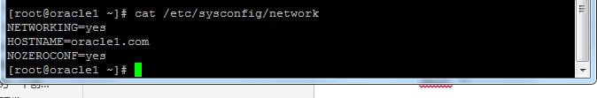

节点二:

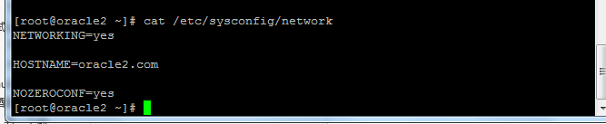

## 1.5、安装Grid Infrastructure

### 1.5.1、解压安装文件

### 1.5.2、安装GRID

xhost +

su - grid

export DISPLAY=:1.0

export LANG='US'

运行./runInstaller

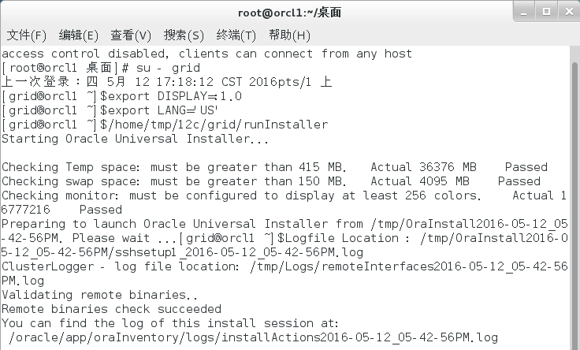

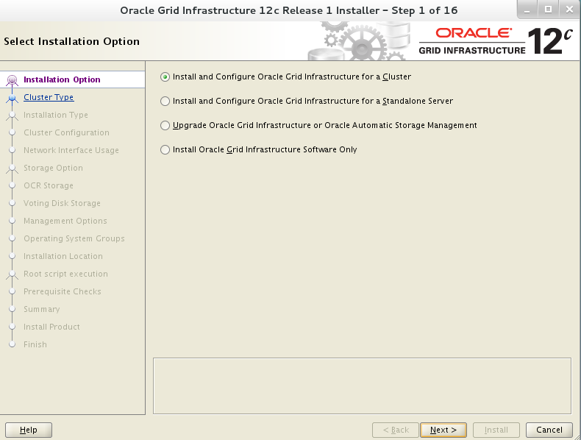

### 1.5.3、指定安装和配置GridCluster

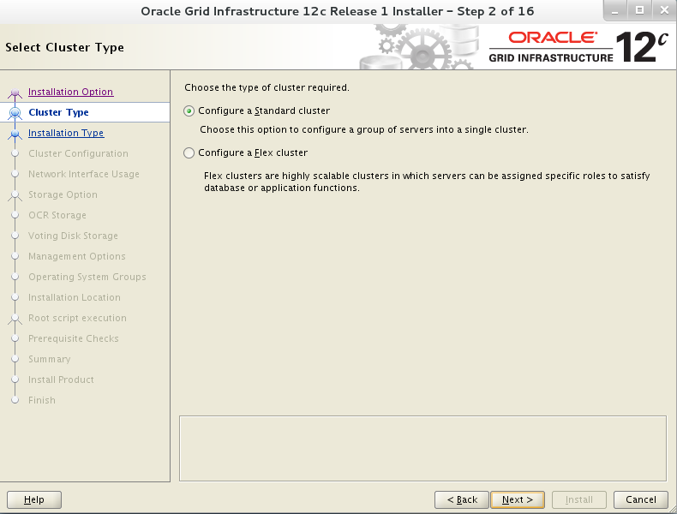

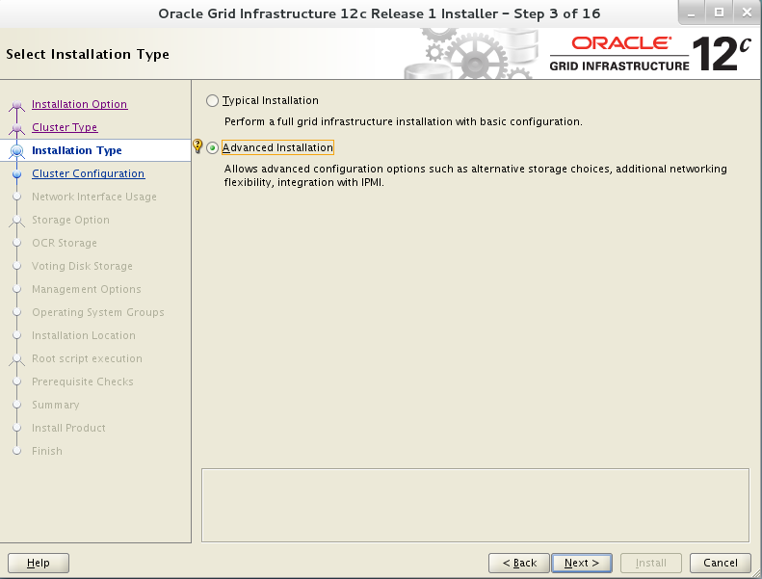

### 1.5.4、选择产品语言，添加简体中文

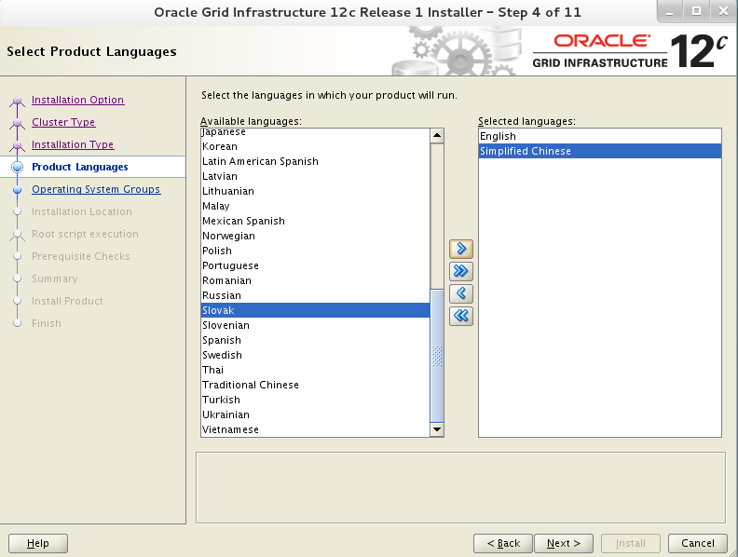

### 配置SCAN

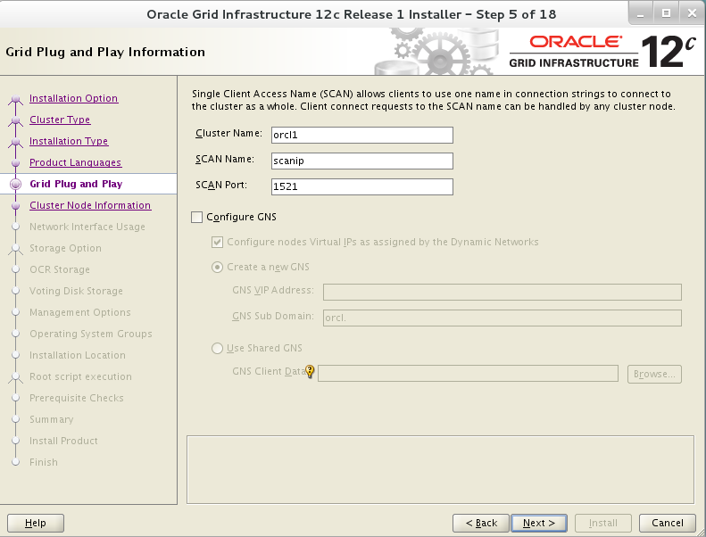

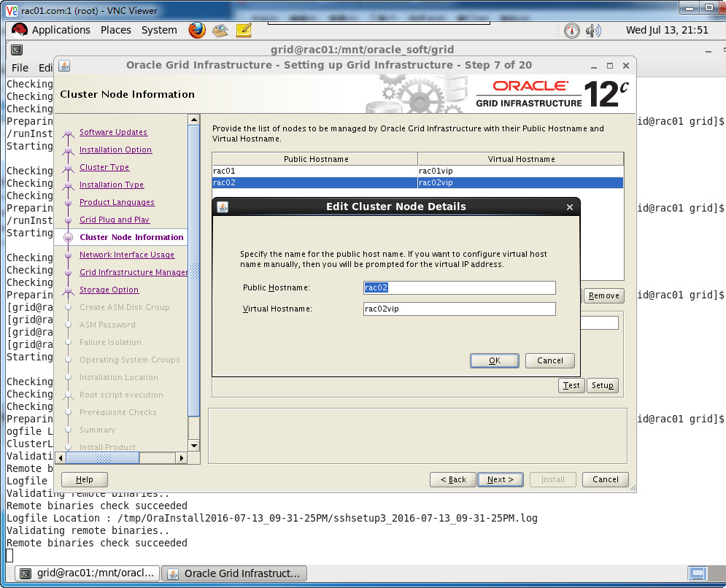

### 配置节点IP与ssh测试

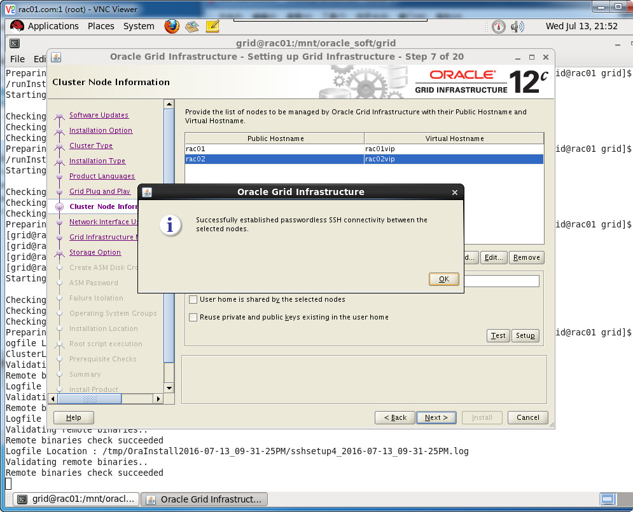

### 选择网卡

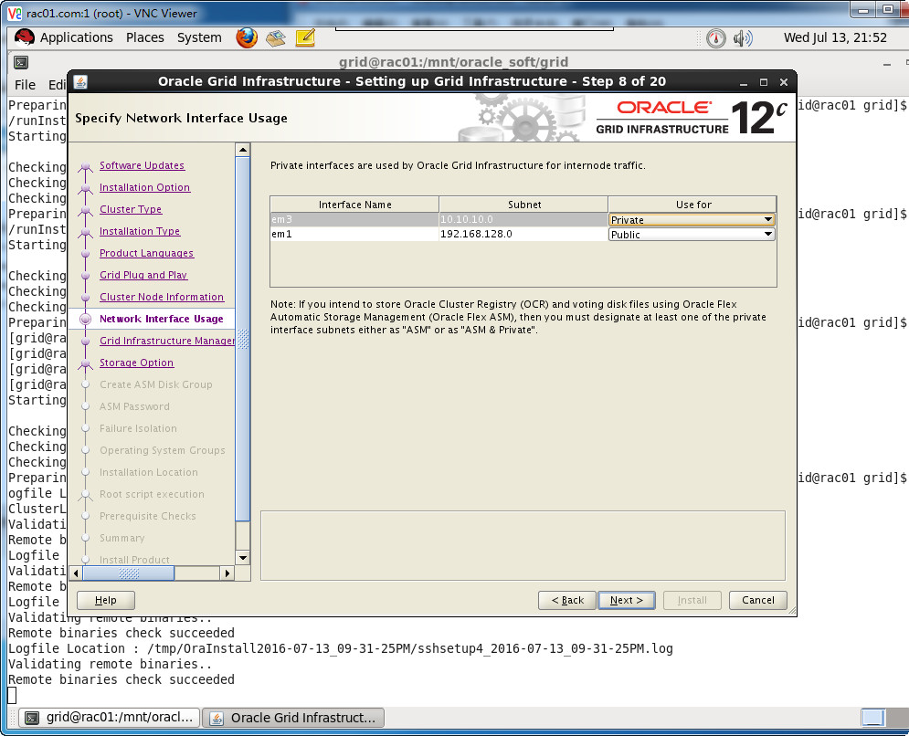

### 选择Shared File System

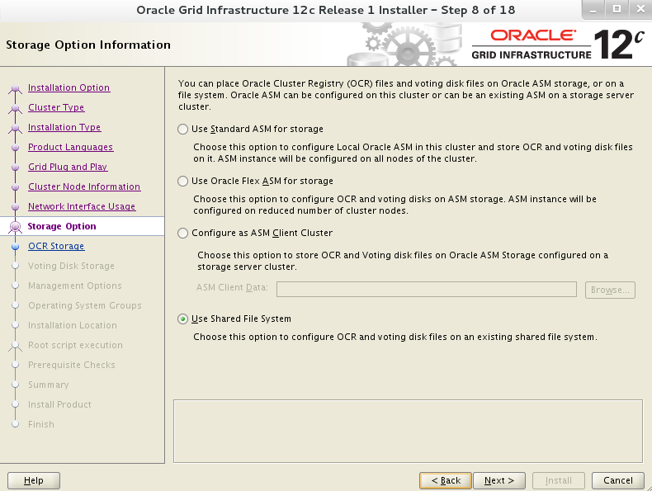

### 选择Ocr File Location

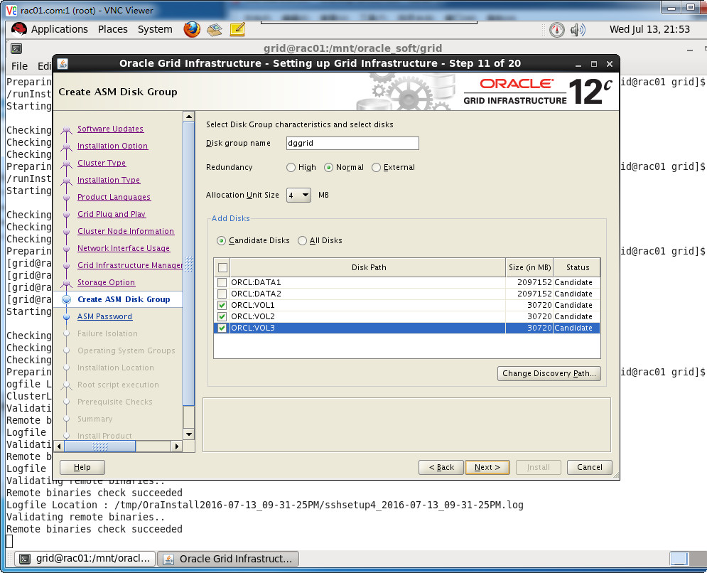

### 选择Create ASM Disk Group



### 配置ASM 管理密码

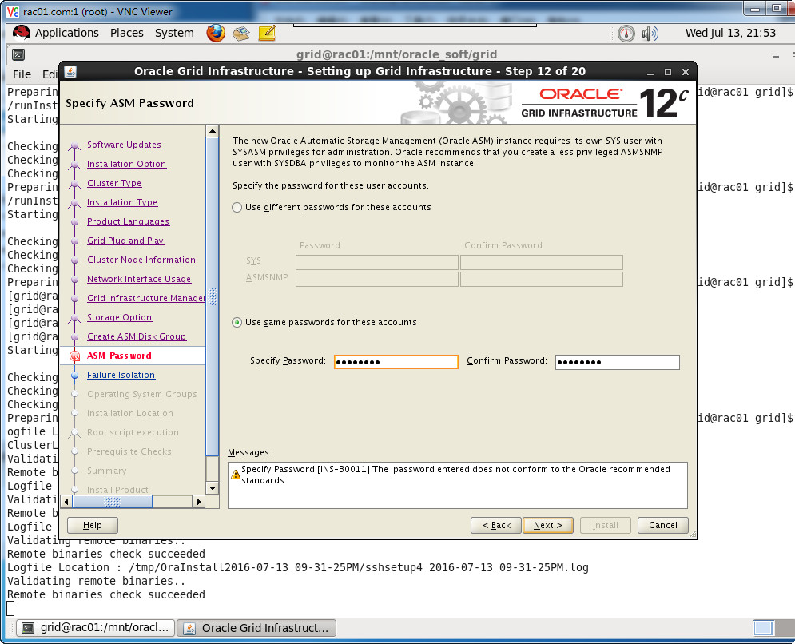

### 1.6.9、选择默认

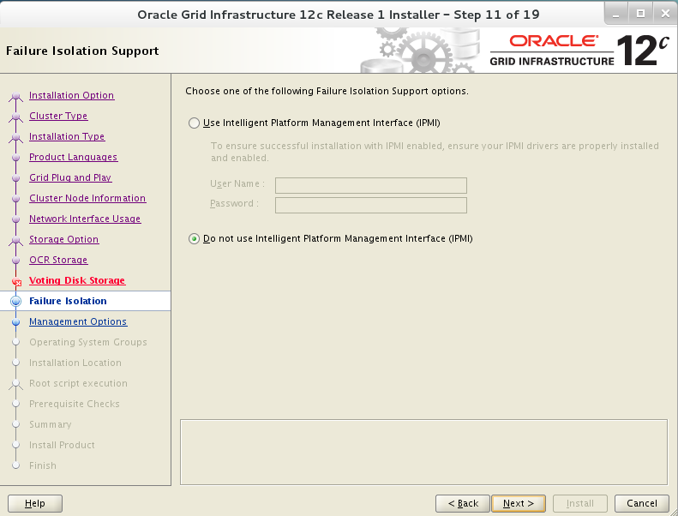

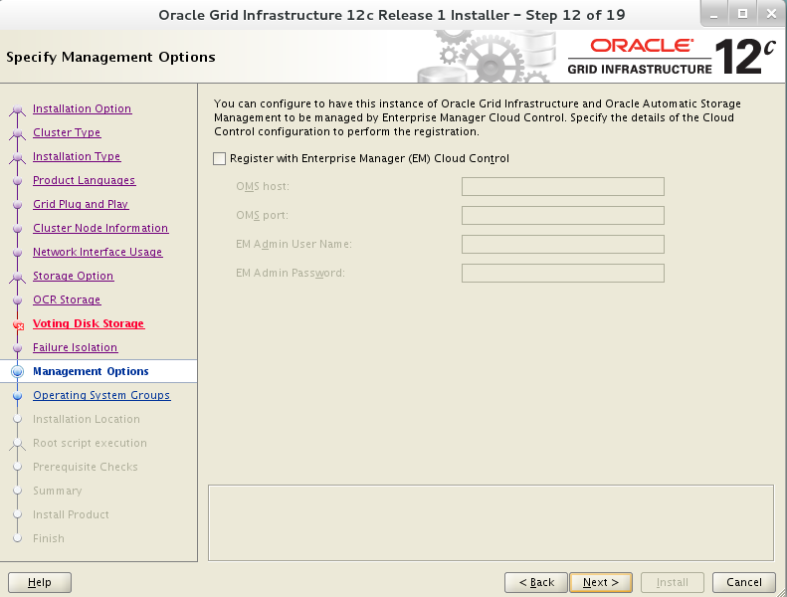

### 选择操作系统组数

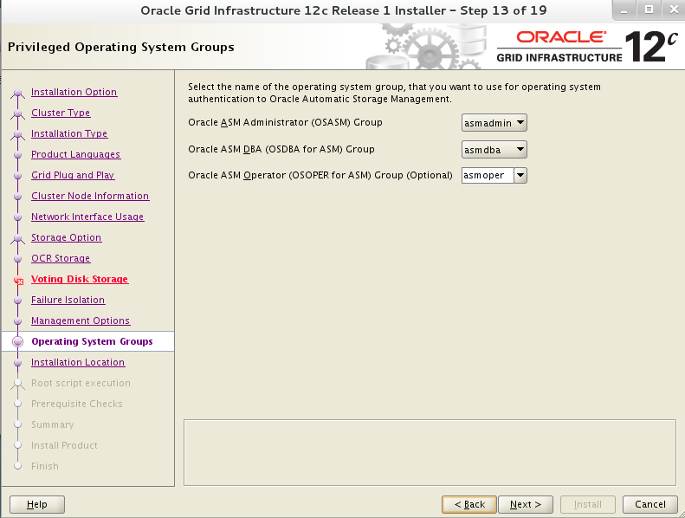

### 1.6.11、选择ORACLE_BASE和ORACLE_HOME

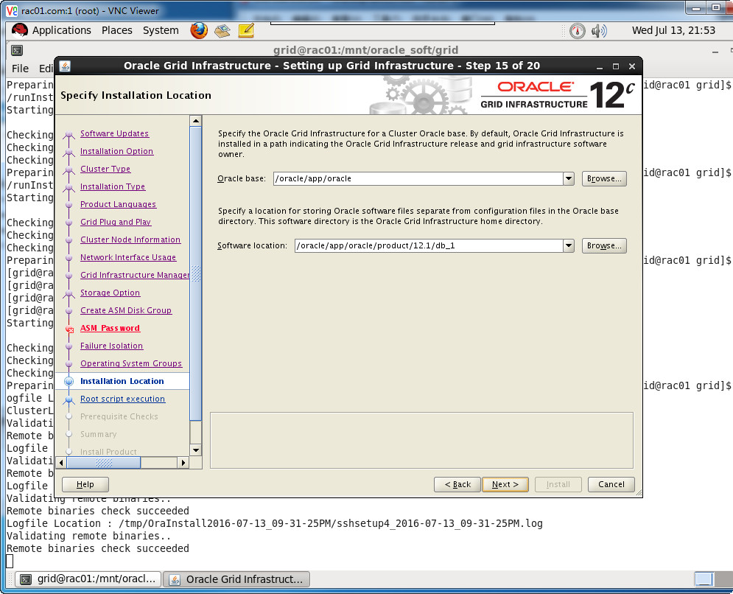

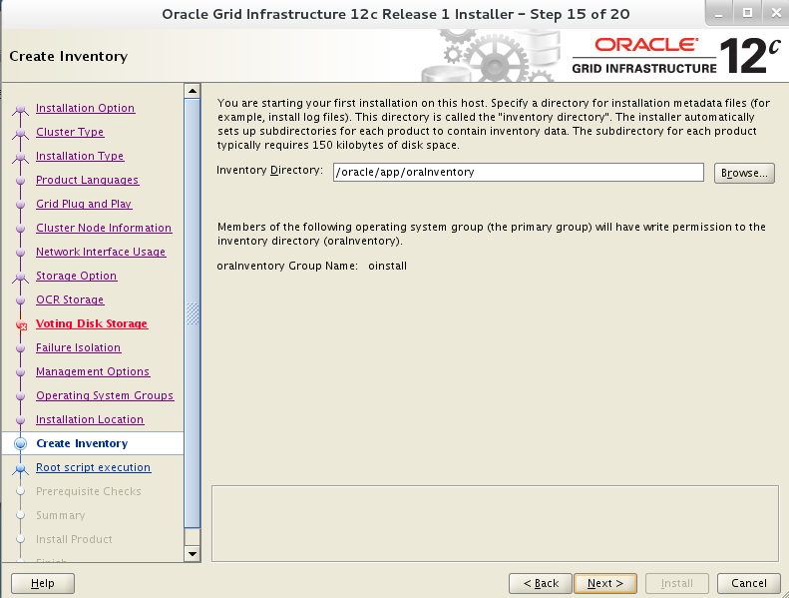

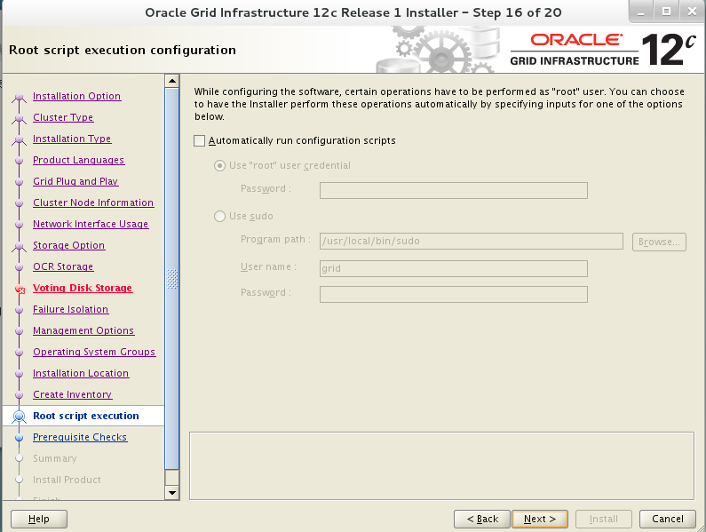

### 操作系统环境检测

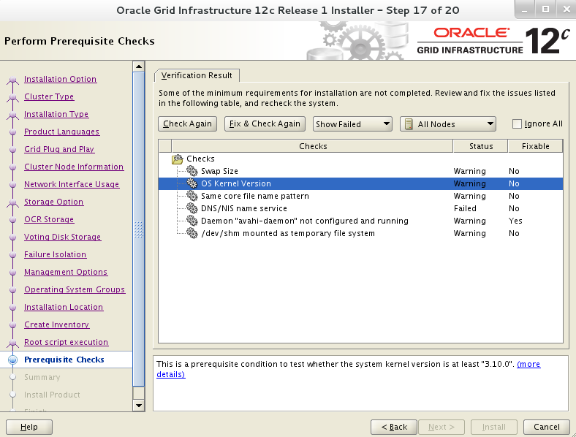

### 安装程序汇总

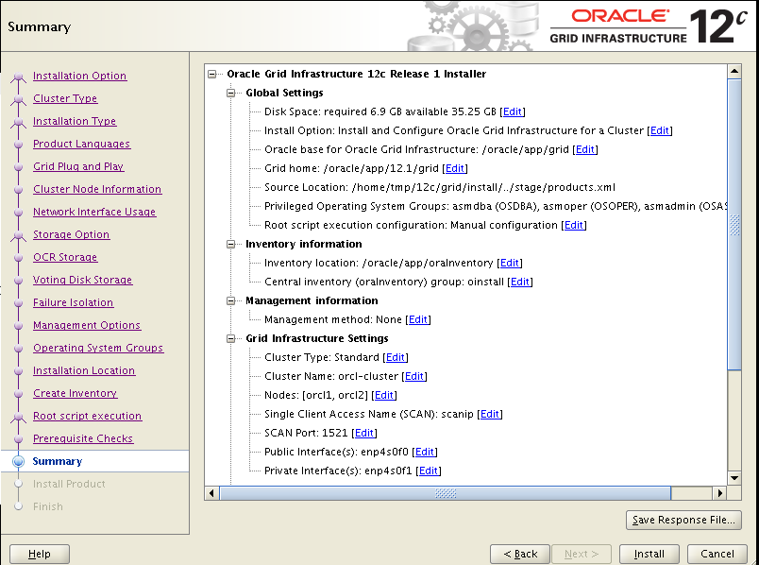

### 开始安装

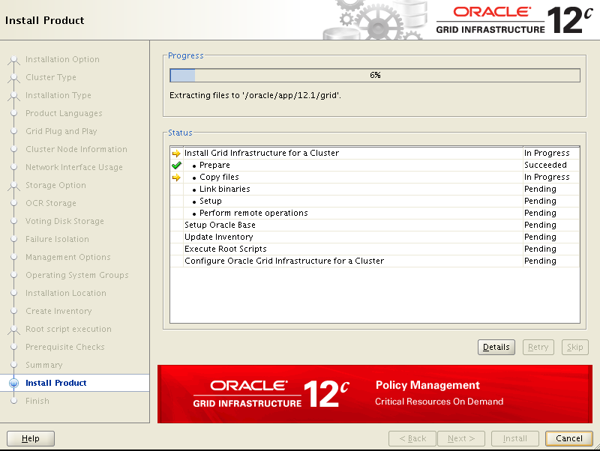

### 1.6.15、按照提示在主机上运行orainstRoot.sh和root.sh

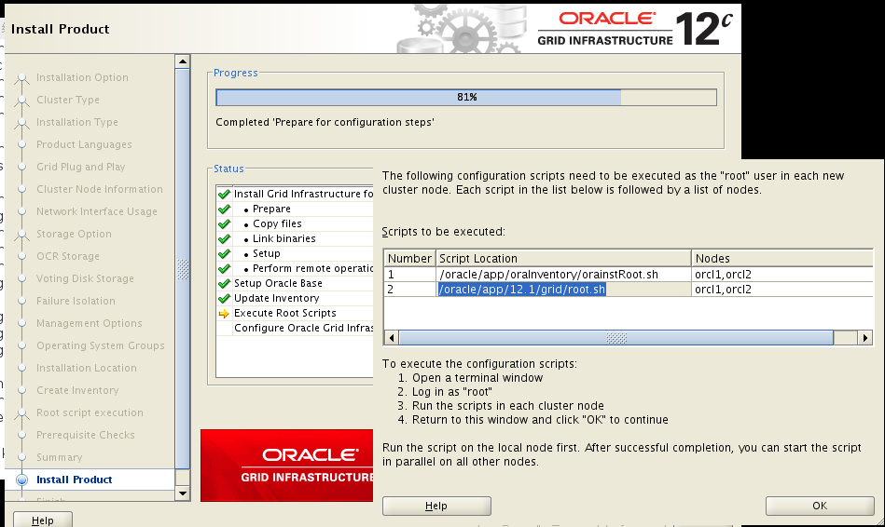

|  |
| --- |
| **节点ORACLE1**  [root@oracle1 oraInventory]# ./orainstRoot.sh  Changing permissions of /oracle/app/oraInventory.  Adding read,write permissions for group.  Removimng read,write,execute permissions for world.  Changing groupname of /oracle/app/oraInventory to oinstall.  The execution of the script is complete.  [root@oracle1 oraInventory]#  **节点ORACLE2**  [root@oracle2 oraInventory]# ./orainstRoot.sh  Changing permissions of /oracle/app/oraInventory.  Adding read,write permissions for group.  Removimng read,write,execute permissions for world.  Changing groupname of /oracle/app/oraInventory to oinstall.  The execution of the script is complete.  [root@oracle2 oraInventory]#  **节点ORACLE1**  [root@oracle1 ~]# /oracle/app/12.1/grid/root.sh  Performing root user operation.  The following envimronment variables are set as:  ORACLE_OWNER= grid  ORACLE_HOME= /oracle/app/12.1/grid  Enter the full pathname of the local bin directory: [/usr/local/bin]:  The contents of "dbhome" have not changed. No need to overwrite.  The contents of "oraenv" have not changed. No need to overwrite.  The contents of "coraenv" have not changed. No need to overwrite.  Creating /etc/oratab file...  Entries will be added to the /etc/oratab file as needed by  Database Configuration Assistant when a database is created  Finished running generic part of root script.  Now product-specific root actions will be performed.  Using configuration parameter file: /oracle/app/12.1/grid/crs/install/crsconfig_params  2016/05/13 10:49:39 CLSRSC-4001: Installing Oracle Trace File Analyzer (TFA) Collector.  2016/05/13 10:50:24 CLSRSC-4002: Successfully installed Oracle Trace File Analyzer (TFA) Collector.  2016/05/13 10:50:25 CLSRSC-363: User ignored prerequisites during installation  OLR initialization - successful  root wallet  root wallet cert  root cert export  peer wallet  profile reader wallet  pa wallet  peer wallet keys  pa wallet keys  peer cert request  pa cert request  peer cert  pa cert  peer root cert TP  profile reader root cert TP  pa root cert TP  peer pa cert TP  pa peer cert TP  profile reader pa cert TP  profile reader peer cert TP  peer user cert  pa user cert  2016/05/13 10:51:17 CLSRSC-330: Adding Clusterware entries to file 'oracle-ohasd.servimce'  CRS-4133: Oracle High Availability Servimces has been stopped.  CRS-4123: Oracle High Availability Servimces has been started.  CRS-4133: Oracle High Availability Servimces has been stopped.  CRS-4123: Oracle High Availability Servimces has been started.  CRS-2672: Attempting to start 'ora.evmd' on 'oracle1'  CRS-2672: Attempting to start 'ora.mdnsd' on 'oracle1'  CRS-2676: Start of 'ora.mdnsd' on 'oracle1' succeeded  CRS-2676: Start of 'ora.evmd' on 'oracle1' succeeded  CRS-2672: Attempting to start 'ora.gpnpd' on 'oracle1'  CRS-2676: Start of 'ora.gpnpd' on 'oracle1' succeeded  CRS-2672: Attempting to start 'ora.cssdmonitor' on 'oracle1'  CRS-2672: Attempting to start 'ora.gipcd' on 'oracle1'  CRS-2676: Start of 'ora.cssdmonitor' on 'oracle1' succeeded  CRS-2676: Start of 'ora.gipcd' on 'oracle1' succeeded  CRS-2672: Attempting to start 'ora.cssd' on 'oracle1'  CRS-2672: Attempting to start 'ora.diskmon' on 'oracle1'  CRS-2676: Start of 'ora.diskmon' on 'oracle1' succeeded  CRS-2676: Start of 'ora.cssd' on 'oracle1' succeeded  CRS-2672: Attempting to start 'ora.crf' on 'oracle1'  CRS-2672: Attempting to start 'ora.storage' on 'oracle1'  CRS-2676: Start of 'ora.storage' on 'oracle1' succeeded  CRS-2676: Start of 'ora.crf' on 'oracle1' succeeded  CRS-2672: Attempting to start 'ora.crsd' on 'oracle1'  CRS-2676: Start of 'ora.crsd' on 'oracle1' succeeded  Now formatting voting disk: /home/ASM/crs1/storage/vdsk1.  Now formatting voting disk: /home/ASM/crs2/storage/vdsk2.  Now formatting voting disk: /home/ASM/crs3/storage/vdsk3.  CRS-4603: Successful addition of voting disk /home/ASM/crs1/storage/vdsk1.  CRS-4603: Successful addition of voting disk /home/ASM/crs2/storage/vdsk2.  CRS-4603: Successful addition of voting disk /home/ASM/crs3/storage/vdsk3.  ## STATE File Universal Id File Name Disk group  -- ----- ----------------- --------- ---------  1. ONLINE 610309812a3a4f1fbf956231de67d686 (/home/ASM/crs1/storage/vdsk1) []  2. ONLINE a7de12a488b84f01bf97a537c81e3d6b (/home/ASM/crs2/storage/vdsk2) []  3. ONLINE 92a980ed27854fd8bf31b89ca069c3af (/home/ASM/crs3/storage/vdsk3) []  Located 3 voting disk(s).  CRS-2791: Starting shutdown of Oracle High Availability Servimces-managed resources on 'oracle1'  CRS-2673: Attempting to stop 'ora.crsd' on 'oracle1'  CRS-2677: Stop of 'ora.crsd' on 'oracle1' succeeded  CRS-2673: Attempting to stop 'ora.crf' on 'oracle1'  CRS-2673: Attempting to stop 'ora.storage' on 'oracle1'  CRS-2673: Attempting to stop 'ora.mdnsd' on 'oracle1'  CRS-2673: Attempting to stop 'ora.gpnpd' on 'oracle1'  CRS-2677: Stop of 'ora.storage' on 'oracle1' succeeded  CRS-2673: Attempting to stop 'ora.ctssd' on 'oracle1'  CRS-2673: Attempting to stop 'ora.evmd' on 'oracle1'  CRS-2677: Stop of 'ora.crf' on 'oracle1' succeeded  CRS-2677: Stop of 'ora.gpnpd' on 'oracle1' succeeded  CRS-2677: Stop of 'ora.mdnsd' on 'oracle1' succeeded  CRS-2677: Stop of 'ora.ctssd' on 'oracle1' succeeded  CRS-2677: Stop of 'ora.evmd' on 'oracle1' succeeded  CRS-2673: Attempting to stop 'ora.cssd' on 'oracle1'  CRS-2677: Stop of 'ora.cssd' on 'oracle1' succeeded  CRS-2673: Attempting to stop 'ora.gipcd' on 'oracle1'  CRS-2677: Stop of 'ora.gipcd' on 'oracle1' succeeded  CRS-2793: Shutdown of Oracle High Availability Servimces-managed resources on 'oracle1' has completed  CRS-4133: Oracle High Availability Servimces has been stopped.  CRS-4123: Starting Oracle High Availability Servimces-managed resources  CRS-2672: Attempting to start 'ora.mdnsd' on 'oracle1'  CRS-2672: Attempting to start 'ora.evmd' on 'oracle1'  CRS-2676: Start of 'ora.mdnsd' on 'oracle1' succeeded  CRS-2676: Start of 'ora.evmd' on 'oracle1' succeeded  CRS-2672: Attempting to start 'ora.gpnpd' on 'oracle1'  CRS-2676: Start of 'ora.gpnpd' on 'oracle1' succeeded  CRS-2672: Attempting to start 'ora.gipcd' on 'oracle1'  CRS-2676: Start of 'ora.gipcd' on 'oracle1' succeeded  CRS-2672: Attempting to start 'ora.cssdmonitor' on 'oracle1'  CRS-2676: Start of 'ora.cssdmonitor' on 'oracle1' succeeded  CRS-2672: Attempting to start 'ora.cssd' on 'oracle1'  CRS-2672: Attempting to start 'ora.diskmon' on 'oracle1'  CRS-2676: Start of 'ora.diskmon' on 'oracle1' succeeded  CRS-2676: Start of 'ora.cssd' on 'oracle1' succeeded  CRS-2672: Attempting to start 'ora.cluster_interconnect.haip' on 'oracle1'  CRS-2672: Attempting to start 'ora.ctssd' on 'oracle1'  CRS-2672: Attempting to start 'ora.storage' on 'oracle1'  CRS-2676: Start of 'ora.storage' on 'oracle1' succeeded  CRS-2676: Start of 'ora.ctssd' on 'oracle1' succeeded  CRS-2672: Attempting to start 'ora.crf' on 'oracle1'  CRS-2676: Start of 'ora.crf' on 'oracle1' succeeded  CRS-2672: Attempting to start 'ora.crsd' on 'oracle1'  CRS-2676: Start of 'ora.crsd' on 'oracle1' succeeded  CRS-2676: Start of 'ora.cluster_interconnect.haip' on 'oracle1' succeeded  CRS-6023: Starting Oracle Cluster Ready Servimces-managed resources  CRS-6017: Processing resource auto-start for servers: oracle1  CRS-6016: Resource auto-start has completed for server oracle1  CRS-6024: Completed start of Oracle Cluster Ready Servimces-managed resources  CRS-4123: Oracle High Availability Servimces has been started.  2016/05/13 10:55:41 CLSRSC-343: Successfully started Oracle Clusterware stack  软件包准备中...  cvuqdisk-1.0.9-1.x86_64  2016/05/13 10:57:58 CLSRSC-325: Configure Oracle Grid Infrastructure for a Cluster ... succeeded  [root@oracle1 ~]# pwd  /root  **节点ORACLE2**  [root@oracle2 ~]# /oracle/app/12.1/grid/root.sh  Performing root user operation.  The following envimronment variables are set as:  ORACLE_OWNER= grid  ORACLE_HOME= /oracle/app/12.1/grid  Enter the full pathname of the local bin directory: [/usr/local/bin]:  The contents of "dbhome" have not changed. No need to overwrite.  The contents of "oraenv" have not changed. No need to overwrite.  The contents of "coraenv" have not changed. No need to overwrite.  Creating /etc/oratab file...  Entries will be added to the /etc/oratab file as needed by  Database Configuration Assistant when a database is created  Finished running generic part of root script.  Now product-specific root actions will be performed.  Using configuration parameter file: /oracle/app/12.1/grid/crs/install/crsconfig_params  2016/05/13 10:58:32 CLSRSC-4001: Installing Oracle Trace File Analyzer (TFA) Collector.  2016/05/13 10:59:09 CLSRSC-4002: Successfully installed Oracle Trace File Analyzer (TFA) Collector.  2016/05/13 10:59:10 CLSRSC-363: User ignored prerequisites during installation  OLR initialization - successful  2016/05/13 10:59:41 CLSRSC-330: Adding Clusterware entries to file 'oracle-ohasd.servimce'  CRS-4133: Oracle High Availability Servimces has been stopped.  CRS-4123: Oracle High Availability Servimces has been started.  CRS-4133: Oracle High Availability Servimces has been stopped.  CRS-4123: Oracle High Availability Servimces has been started.  CRS-4133: Oracle High Availability Servimces has been stopped.  CRS-4123: Starting Oracle High Availability Servimces-managed resources  CRS-2672: Attempting to start 'ora.mdnsd' on 'oracle2'  CRS-2672: Attempting to start 'ora.evmd' on 'oracle2'  CRS-2676: Start of 'ora.mdnsd' on 'oracle2' succeeded  CRS-2676: Start of 'ora.evmd' on 'oracle2' succeeded  CRS-2672: Attempting to start 'ora.gpnpd' on 'oracle2'  CRS-2676: Start of 'ora.gpnpd' on 'oracle2' succeeded  CRS-2672: Attempting to start 'ora.gipcd' on 'oracle2'  CRS-2676: Start of 'ora.gipcd' on 'oracle2' succeeded  CRS-2672: Attempting to start 'ora.cssdmonitor' on 'oracle2'  CRS-2676: Start of 'ora.cssdmonitor' on 'oracle2' succeeded  CRS-2672: Attempting to start 'ora.cssd' on 'oracle2'  CRS-2672: Attempting to start 'ora.diskmon' on 'oracle2'  CRS-2676: Start of 'ora.diskmon' on 'oracle2' succeeded  CRS-2676: Start of 'ora.cssd' on 'oracle2' succeeded  CRS-2672: Attempting to start 'ora.cluster_interconnect.haip' on 'oracle2'  CRS-2672: Attempting to start 'ora.ctssd' on 'oracle2'  CRS-2672: Attempting to start 'ora.storage' on 'oracle2'  CRS-2676: Start of 'ora.storage' on 'oracle2' succeeded  CRS-2676: Start of 'ora.ctssd' on 'oracle2' succeeded  CRS-2672: Attempting to start 'ora.crf' on 'oracle2'  CRS-2676: Start of 'ora.crf' on 'oracle2' succeeded  CRS-2672: Attempting to start 'ora.crsd' on 'oracle2'  CRS-2676: Start of 'ora.crsd' on 'oracle2' succeeded  CRS-2676: Start of 'ora.cluster_interconnect.haip' on 'oracle2' succeeded  CRS-6017: Processing resource auto-start for servers: oracle2  CRS-2672: Attempting to start 'ora.net1.network' on 'oracle2'  CRS-2676: Start of 'ora.net1.network' on 'oracle2' succeeded  CRS-2672: Attempting to start 'ora.ons' on 'oracle2'  CRS-2676: Start of 'ora.ons' on 'oracle2' succeeded  CRS-6016: Resource auto-start has completed for server oracle2  CRS-6024: Completed start of Oracle Cluster Ready Servimces-managed resources  CRS-4123: Oracle High Availability Servimces has been started.  2016/05/13 11:03:07 CLSRSC-343: Successfully started Oracle Clusterware stack  软件包准备中...  cvuqdisk-1.0.9-1.x86_64  2016/05/13 11:03:26 CLSRSC-325: Configure Oracle Grid Infrastructure for a Cluster ... succeeded  [root@oracle2 ~]# |

### 安装完成

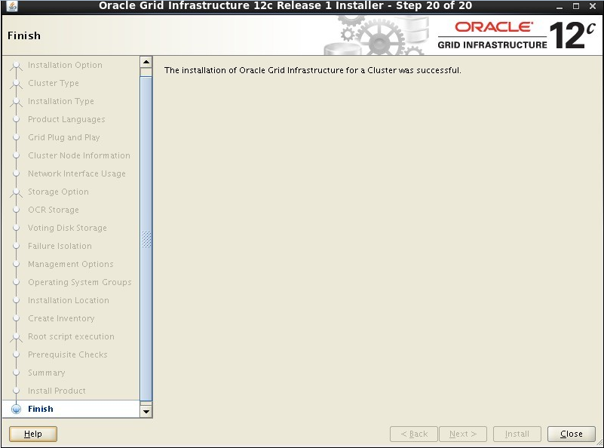

## 安装完成后检查状态

#### 2.1、crs_stat -t

|  |
| --- |
| 节点ORACLE1 [grid@oracle1 ~]$ crs_stat -t  Name Type Target State Host  ------------------------------------------------------------  ora.CRS.dg ora....up.type ONLINE ONLINE oracle1  ora.DATA.dg ora....up.type ONLINE ONLINE oracle1  ora.FLASH.dg ora....up.type ONLINE ONLINE oracle1  ora....ER.lsnr ora....er.type ONLINE ONLINE oracle1  ora....N1.lsnr ora....er.type ONLINE ONLINE oracle1  ora.MGMTLSNR ora....nr.type ONLINE ONLINE oracle1  ora.asm ora.asm.type ONLINE ONLINE oracle1  ora.cvu ora.cvu.type ONLINE ONLINE oracle1  ora.g_xshis.db ora....se.type ONLINE ONLINE oracle1  ora.mgmtdb ora....db.type ONLINE ONLINE oracle1  ora....network ora....rk.type ONLINE ONLINE oracle1  ora.oc4j ora.oc4j.type ONLINE ONLINE oracle1  ora.ons ora.ons.type ONLINE ONLINE oracle1  ora....SM1.asm application ONLINE ONLINE oracle1  ora....E1.lsnr application ONLINE ONLINE oracle1  ora....le1.ons application ONLINE ONLINE oracle1  ora....le1.vip ora....t1.type ONLINE ONLINE oracle1  ora....SM2.asm application ONLINE ONLINE oracle2  ora....E2.lsnr application ONLINE ONLINE oracle2  ora....le2.ons application ONLINE ONLINE oracle2  ora....le2.vip ora....t1.type ONLINE ONLINE oracle2  ora.scan1.vip ora....ip.type ONLINE ONLINE oracle1 |
| 节点ORACLE2 [grid@oracle2 ~]$ crs_stat -t  Name Type Target State Host  ------------------------------------------------------------  ora.CRS.dg ora....up.type ONLINE ONLINE oracle1  ora.DATA.dg ora....up.type ONLINE ONLINE oracle1  ora.FLASH.dg ora....up.type ONLINE ONLINE oracle1  ora....ER.lsnr ora....er.type ONLINE ONLINE oracle1  ora....N1.lsnr ora....er.type ONLINE ONLINE oracle1  ora.MGMTLSNR ora....nr.type ONLINE ONLINE oracle1  ora.asm ora.asm.type ONLINE ONLINE oracle1  ora.cvu ora.cvu.type ONLINE ONLINE oracle1  ora.g_xshis.db ora....se.type ONLINE ONLINE oracle1  ora.mgmtdb ora....db.type ONLINE ONLINE oracle1  ora....network ora....rk.type ONLINE ONLINE oracle1  ora.oc4j ora.oc4j.type ONLINE ONLINE oracle1  ora.ons ora.ons.type ONLINE ONLINE oracle1  ora....SM1.asm application ONLINE ONLINE oracle1  ora....E1.lsnr application ONLINE ONLINE oracle1  ora....le1.ons application ONLINE ONLINE oracle1  ora....le1.vip ora....t1.type ONLINE ONLINE oracle1  ora....SM2.asm application ONLINE ONLINE oracle2  ora....E2.lsnr application ONLINE ONLINE oracle2  ora....le2.ons application ONLINE ONLINE oracle2  ora....le2.vip ora....t1.type ONLINE ONLINE oracle2  ora.scan1.vip ora....ip.type ONLINE ONLINE oracle1 |

#### 2.2、crsctl status res -t

|  |
| --- |
| 节点ORACLE1 [grid@oracle1 ~]$ crsctl status res -t  --------------------------------------------------------------------------------  Name Target State Server State details  --------------------------------------------------------------------------------  Local Resources  --------------------------------------------------------------------------------  ora.CRS.dg  ONLINE ONLINE oracle1 STABLE  ONLINE ONLINE oracle2 STABLE  ora.DATA.dg  ONLINE ONLINE oracle1 STABLE  ONLINE ONLINE oracle2 STABLE  ora.FLASH.dg  ONLINE ONLINE oracle1 STABLE  ONLINE ONLINE oracle2 STABLE  ora.LISTENER.lsnr  ONLINE ONLINE oracle1 STABLE  ONLINE ONLINE oracle2 STABLE  ora.asm  ONLINE ONLINE oracle1 Started,STABLE  ONLINE ONLINE oracle2 Started,STABLE  ora.net1.network  ONLINE ONLINE oracle1 STABLE  ONLINE ONLINE oracle2 STABLE  ora.ons  ONLINE ONLINE oracle1 STABLE  ONLINE ONLINE oracle2 STABLE  --------------------------------------------------------------------------------  Cluster Resources  --------------------------------------------------------------------------------  ora.LISTENER_SCAN1.lsnr  1 ONLINE ONLINE oracle1 STABLE  ora.MGMTLSNR  1 ONLINE ONLINE oracle1 169.254.32.177 10.10  .10.40,STABLE  ora.cvu  1 ONLINE ONLINE oracle1 STABLE  ora.g_xshis.db  1 ONLINE ONLINE oracle1 Open,STABLE  2 ONLINE ONLINE oracle2 Open,STABLE  ora.mgmtdb  1 ONLINE ONLINE oracle1 Open,STABLE  ora.oc4j  1 ONLINE ONLINE oracle1 STABLE  ora.oracle1.vip  1 ONLINE ONLINE oracle1 STABLE  ora.oracle2.vip  1 ONLINE ONLINE oracle2 STABLE  ora.scan1.vip  1 ONLINE ONLINE oracle1 STABLE  -------------------------------------------------------------------------------- |
| 节点ORACLE2 [grid@oracle2 ~]$ crsctl status res -t  --------------------------------------------------------------------------------  Name Target State Server State details  --------------------------------------------------------------------------------  Local Resources  --------------------------------------------------------------------------------  ora.CRS.dg  ONLINE ONLINE oracle1 STABLE  ONLINE ONLINE oracle2 STABLE  ora.DATA.dg  ONLINE ONLINE oracle1 STABLE  ONLINE ONLINE oracle2 STABLE  ora.FLASH.dg  ONLINE ONLINE oracle1 STABLE  ONLINE ONLINE oracle2 STABLE  ora.LISTENER.lsnr  ONLINE ONLINE oracle1 STABLE  ONLINE ONLINE oracle2 STABLE  ora.asm  ONLINE ONLINE oracle1 Started,STABLE  ONLINE ONLINE oracle2 Started,STABLE  ora.net1.network  ONLINE ONLINE oracle1 STABLE  ONLINE ONLINE oracle2 STABLE  ora.ons  ONLINE ONLINE oracle1 STABLE  ONLINE ONLINE oracle2 STABLE  --------------------------------------------------------------------------------  Cluster Resources  --------------------------------------------------------------------------------  ora.LISTENER_SCAN1.lsnr  1 ONLINE ONLINE oracle1 STABLE  ora.MGMTLSNR  1 ONLINE ONLINE oracle1 169.254.32.177 10.10  .10.40,STABLE  ora.cvu  1 ONLINE ONLINE oracle1 STABLE  ora.g_xshis.db  1 ONLINE ONLINE oracle1 Open,STABLE  2 ONLINE ONLINE oracle2 Open,STABLE  ora.mgmtdb  1 ONLINE ONLINE oracle1 Open,STABLE  ora.oc4j  1 ONLINE ONLINE oracle1 STABLE  ora.oracle1.vip  1 ONLINE ONLINE oracle1 STABLE  ora.oracle2.vip  1 ONLINE ONLINE oracle2 STABLE  ora.scan1.vip  1 ONLINE ONLINE oracle1 STABLE  -------------------------------------------------------------------------------- |

## 解压软件

## 4.7、安装ORACLE12c数据库软件

### 4.7.2、运行安装命令

Root xhost +

su - oracle

./runInstaller

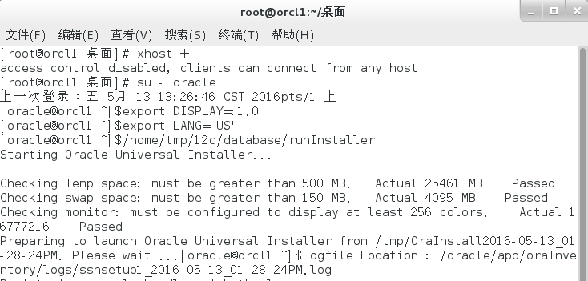

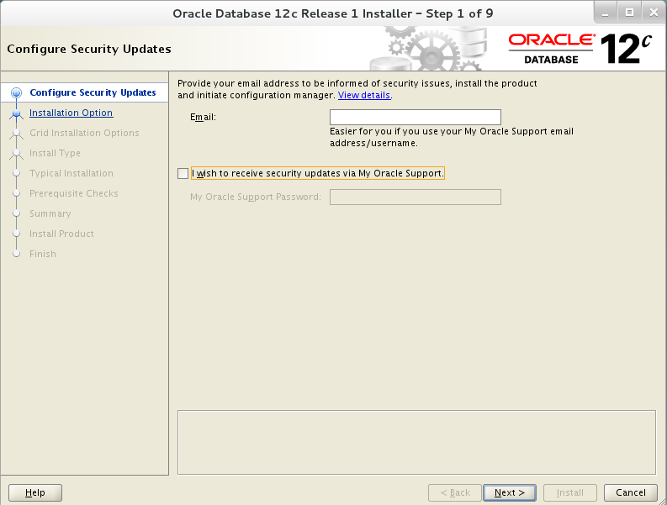

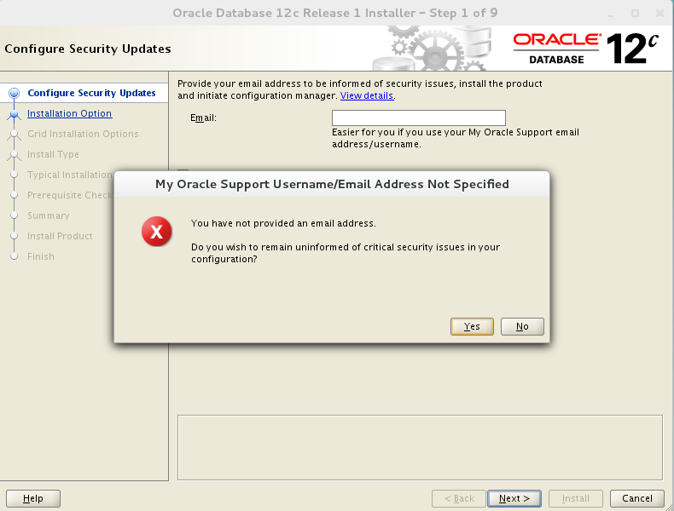

### 配置安装选项，选择install database software only

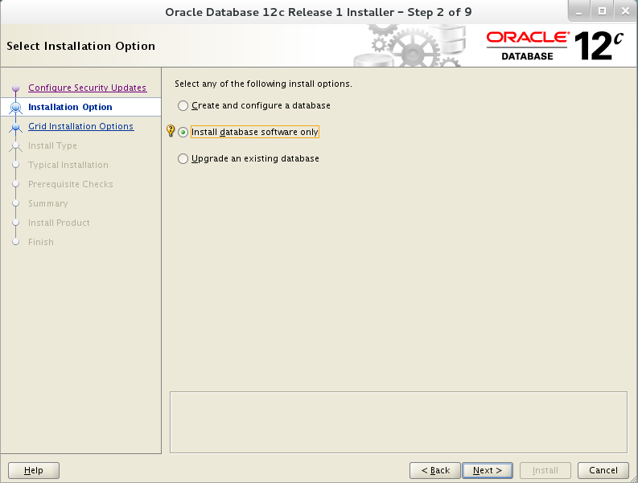

### 配置grid安装选项，选择oracle RAC install database

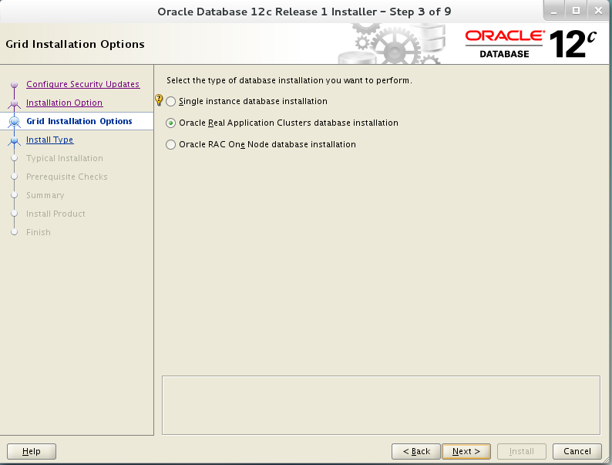

### 选择所有节点，setup SSH，并test SSH

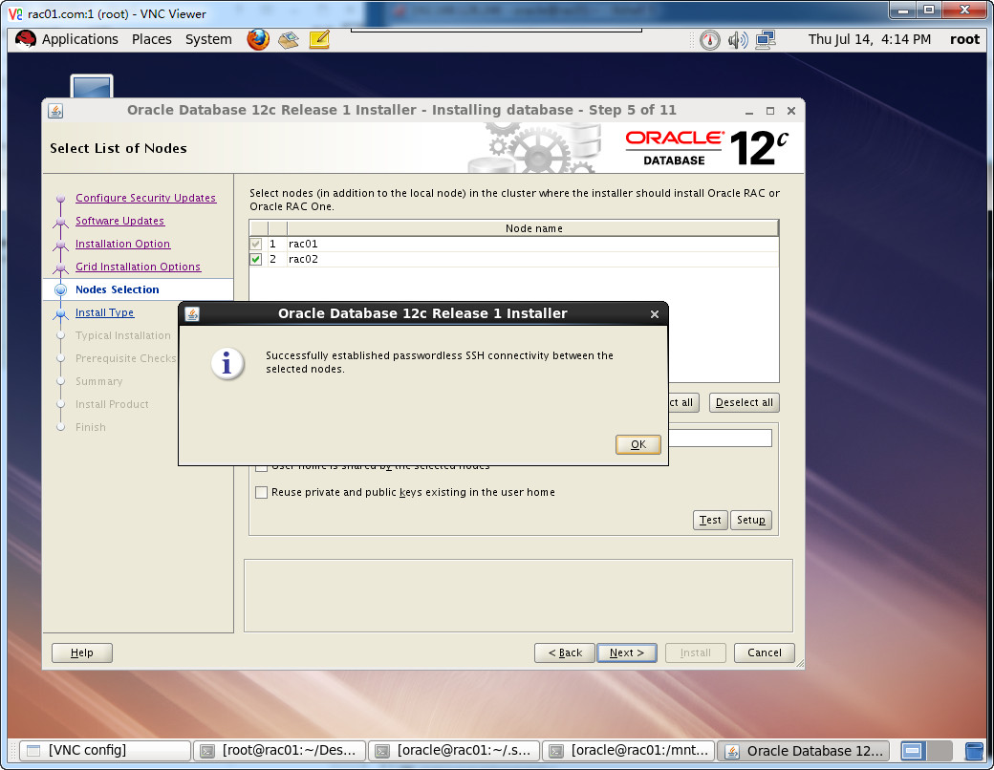

### 选择安装语言

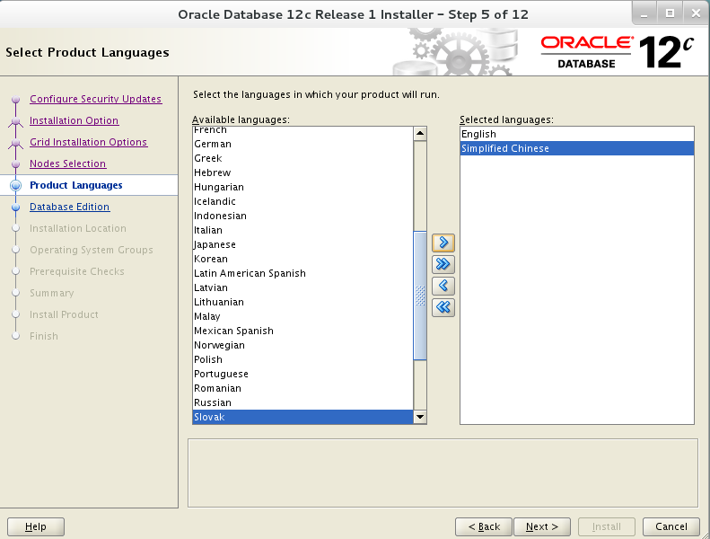

### 选择企业版安装

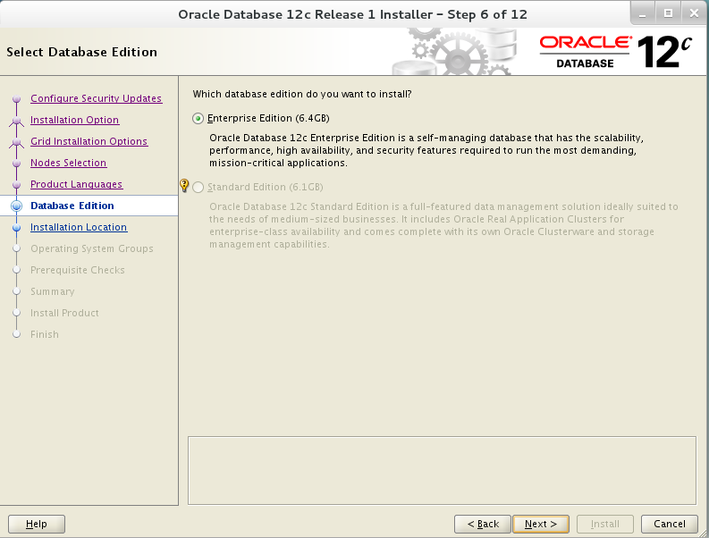

### 选择安装路径

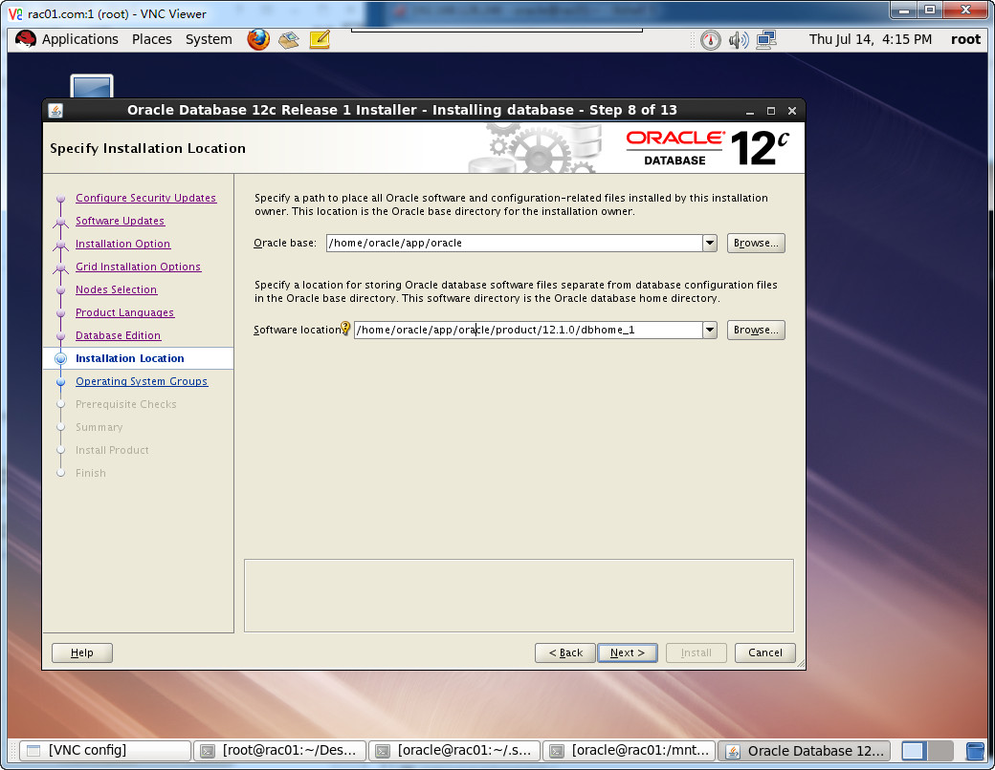

### 默认指定相关组

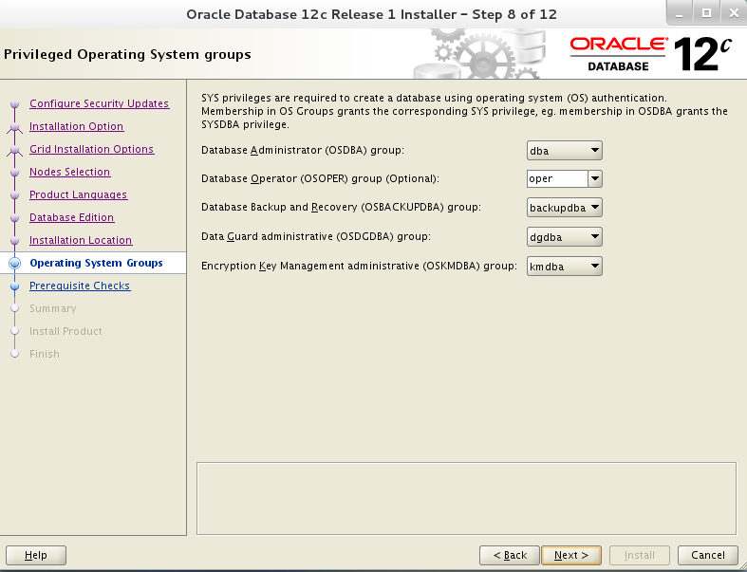

### 安装检查

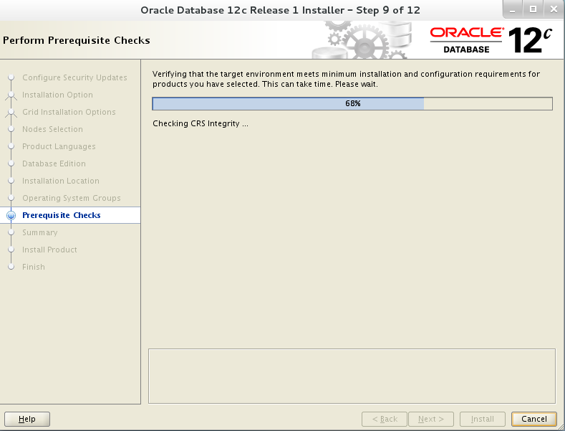

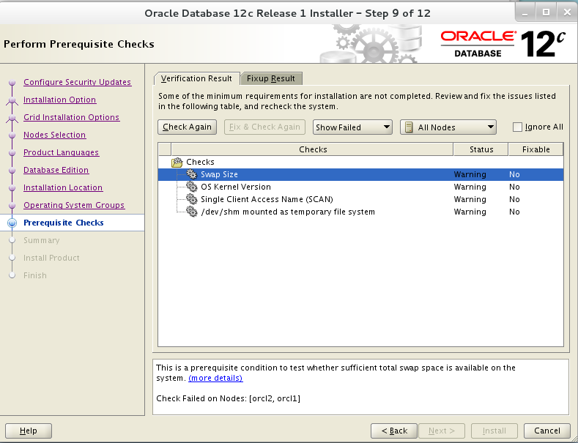

### 安装程序汇总

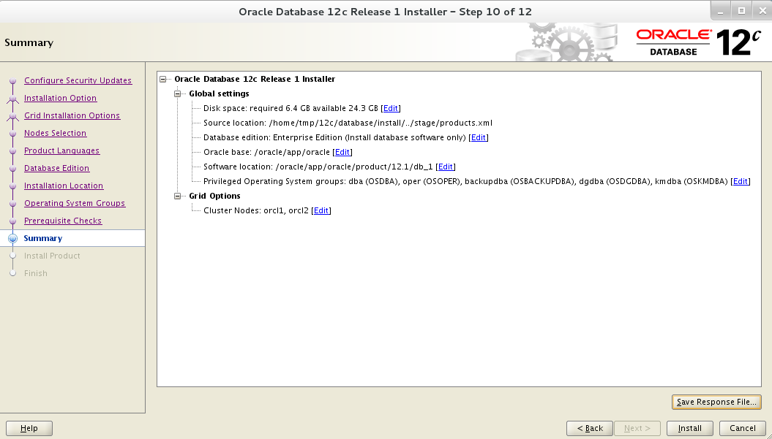

### 开始安装

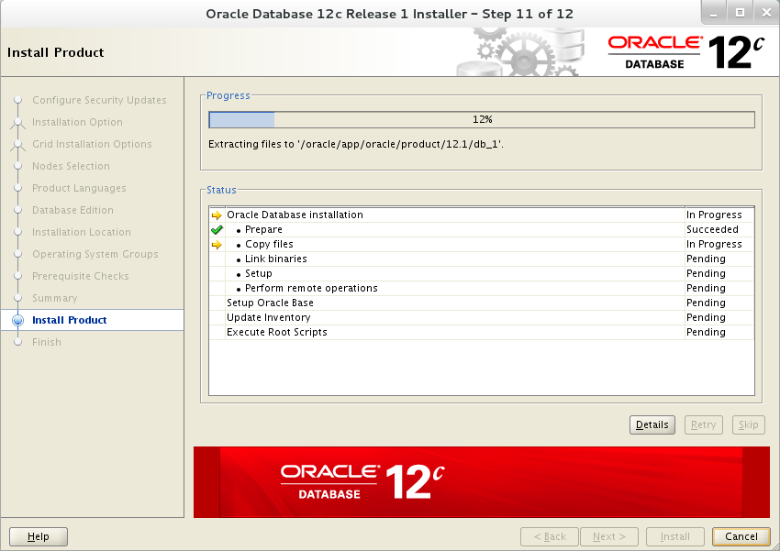

### 安装完成后，主机运行root.sh文件

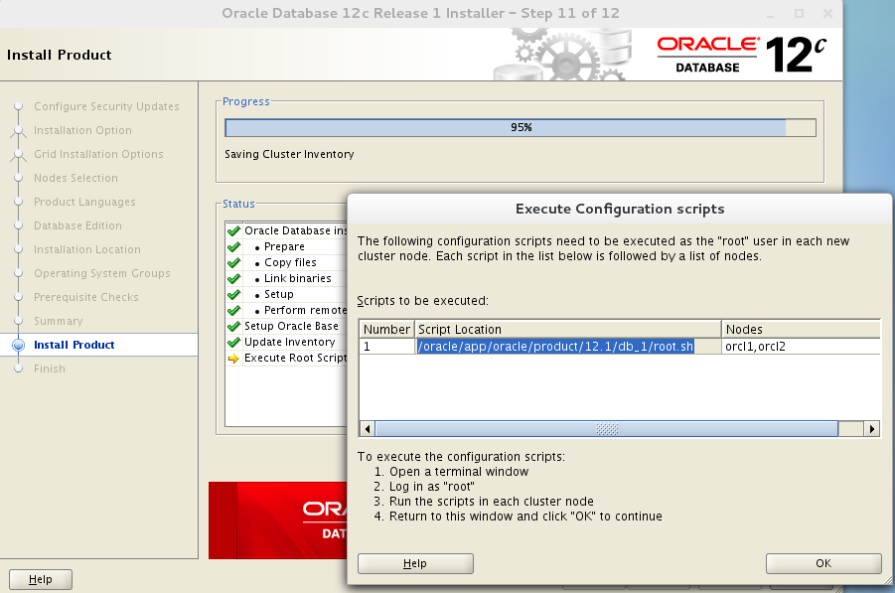

|  |
| --- |
| 节点ORACLE1 [root@oracle1 ~]# /oracle/app/oracle/product/12.1/db_1/root.sh  Performing root user operation.  The following envimronment variables are set as:  ORACLE_OWNER= oracle  ORACLE_HOME= /oracle/app/oracle/product/12.1/db_1  Enter the full pathname of the local bin directory: [/usr/local/bin]:  The contents of "dbhome" have not changed. No need to overwrite.  The contents of "oraenv" have not changed. No need to overwrite.  The contents of "coraenv" have not changed. No need to overwrite.  Entries will be added to the /etc/oratab file as needed by  Database Configuration Assistant when a database is created  Finished running generic part of root script.  Now product-specific root actions will be performed.  [root@oracle1 ~]# |
| 节点ORACLE2 [root@oracle2 ~]# /oracle/app/oracle/product/12.1/db_1/root.sh  Performing root user operation.  The following envimronment variables are set as:  ORACLE_OWNER= oracle  ORACLE_HOME= /oracle/app/oracle/product/12.1/db_1  Enter the full pathname of the local bin directory: [/usr/local/bin]:  The contents of "dbhome" have not changed. No need to overwrite.  The contents of "oraenv" have not changed. No need to overwrite.  The contents of "coraenv" have not changed. No need to overwrite.  Entries will be added to the /etc/oratab file as needed by  Database Configuration Assistant when a database is created  Finished running generic part of root script.  Now product-specific root actions will be performed.  [root@oracle2 ~]# |

### 安装完成

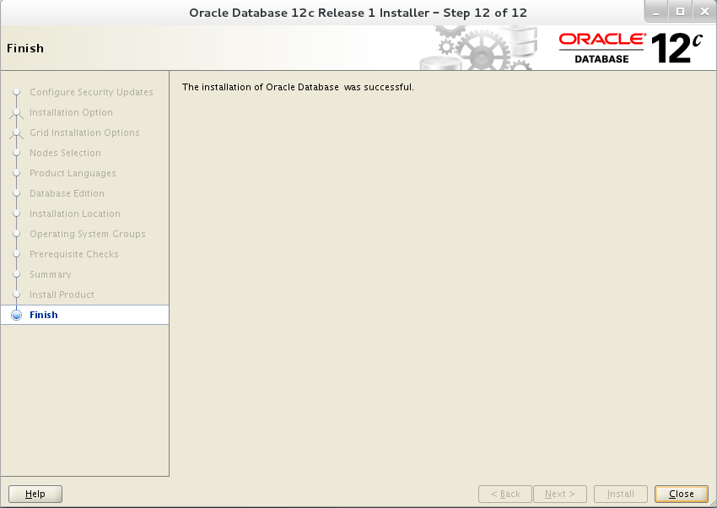

## 创建ORACLE12c数据库实例

Root xhost +

su - oracle

export DISPLAY=:1.0

export LANG='US'

dbca

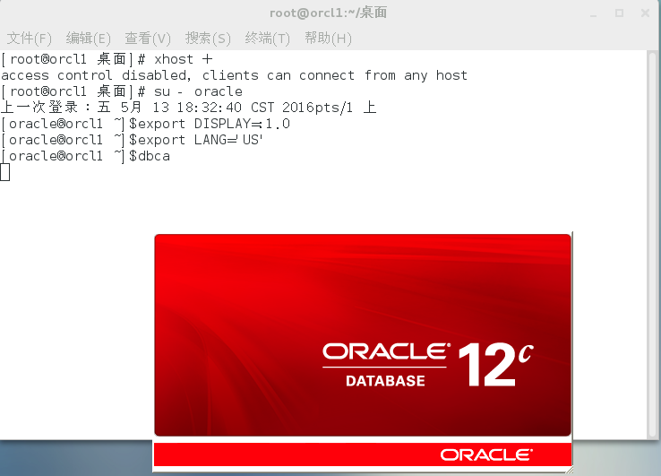

### 选择Create Database

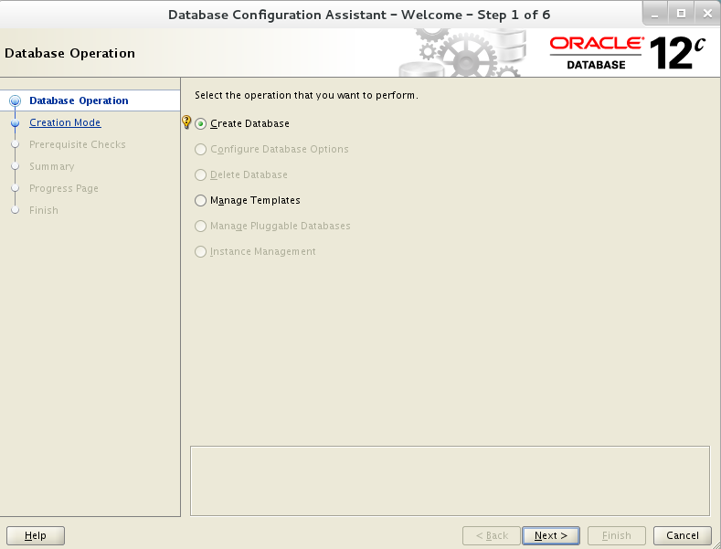

### 选择高级模式

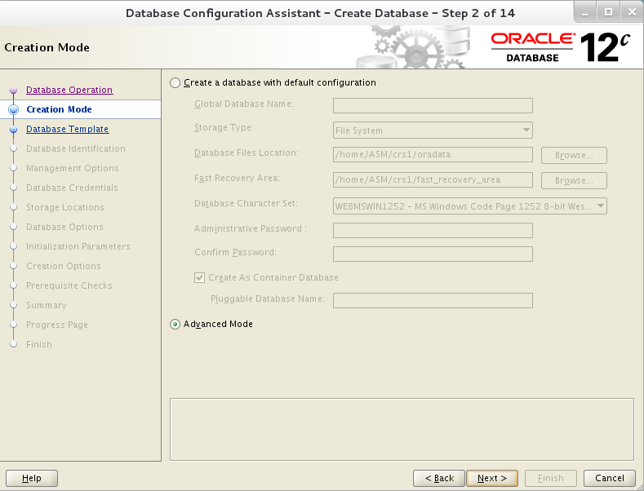

### 选择数据库、配置类型和数据模版

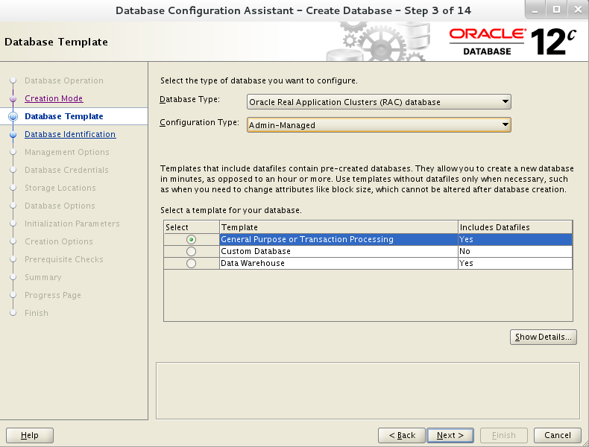

### 输入全域数据库名称和sid前缀

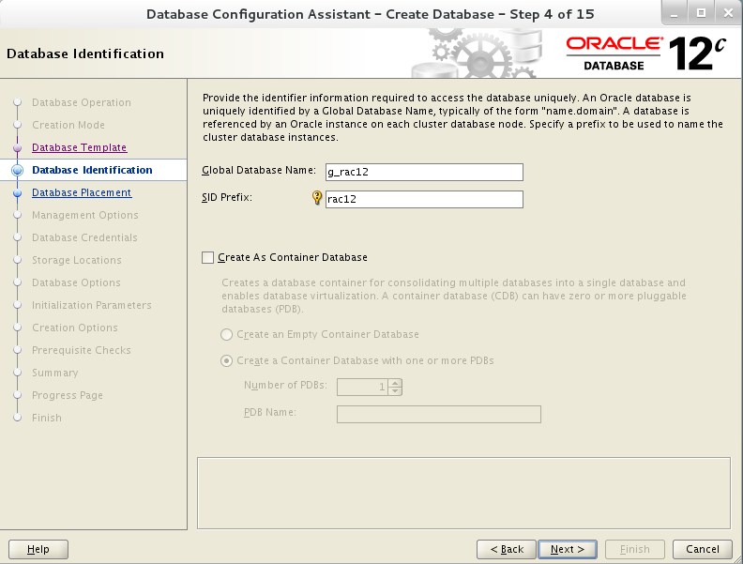

### 选择集群节点

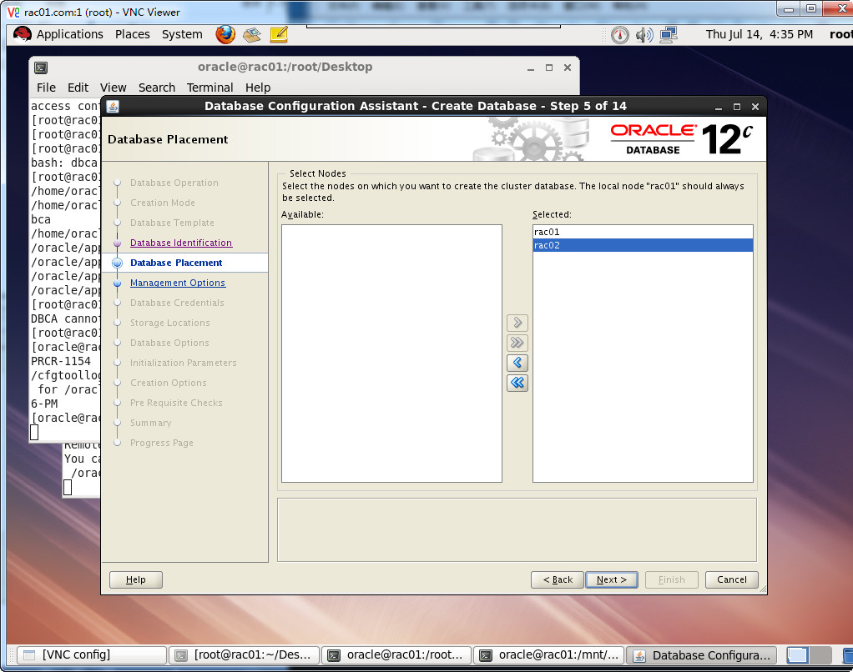

### 配置em

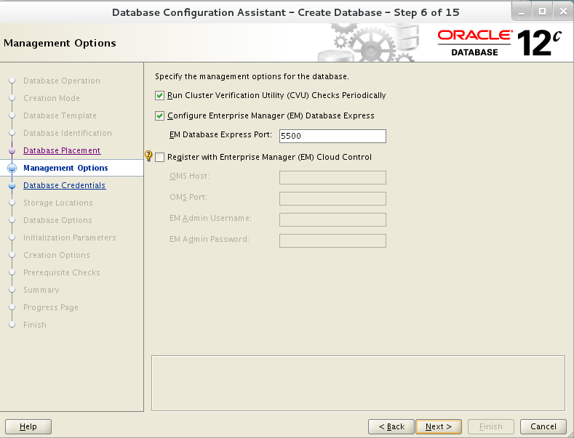

### 设置数据库密码

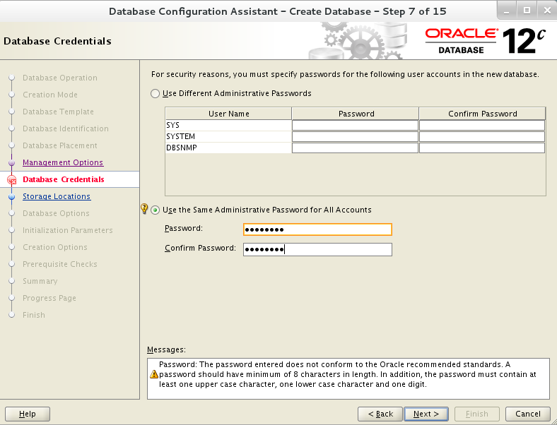

### 选择数据文件保存位置

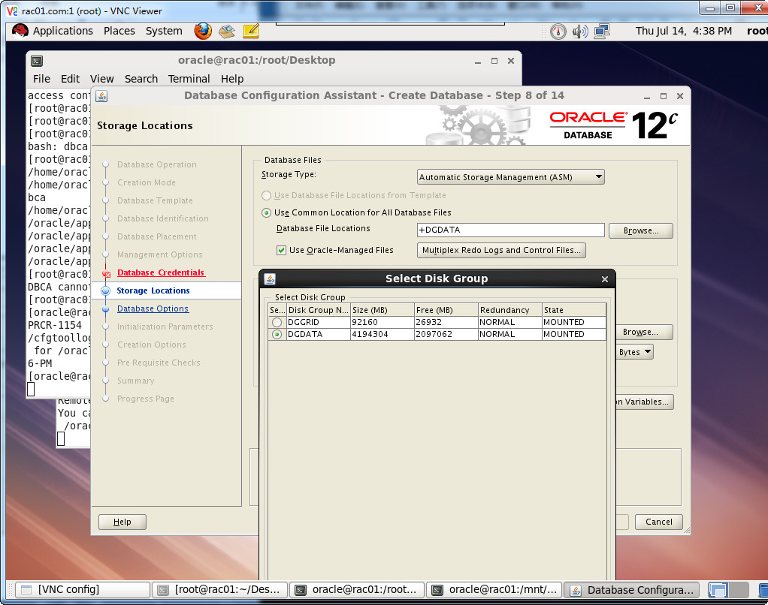

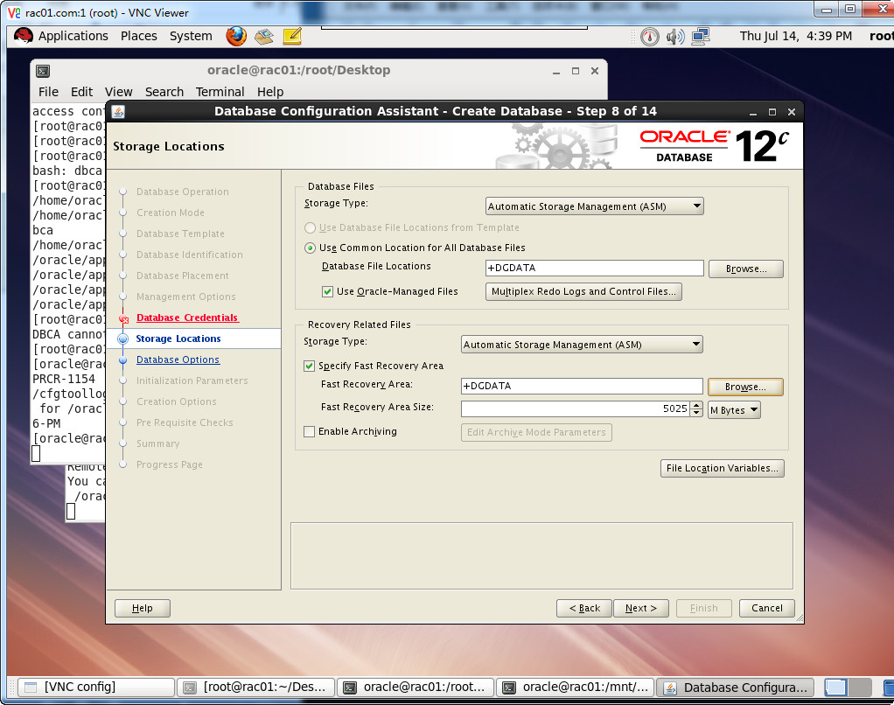

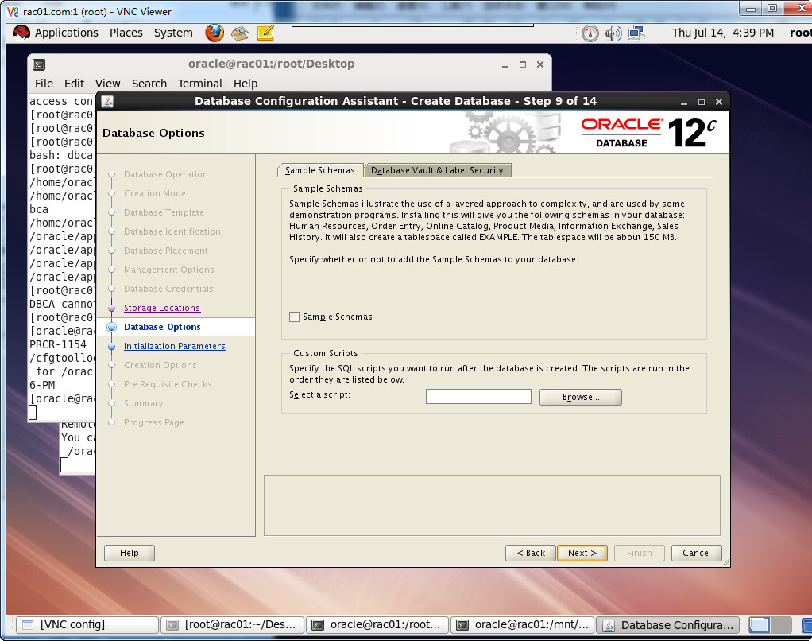

### 配置数据库参数

#### Memory

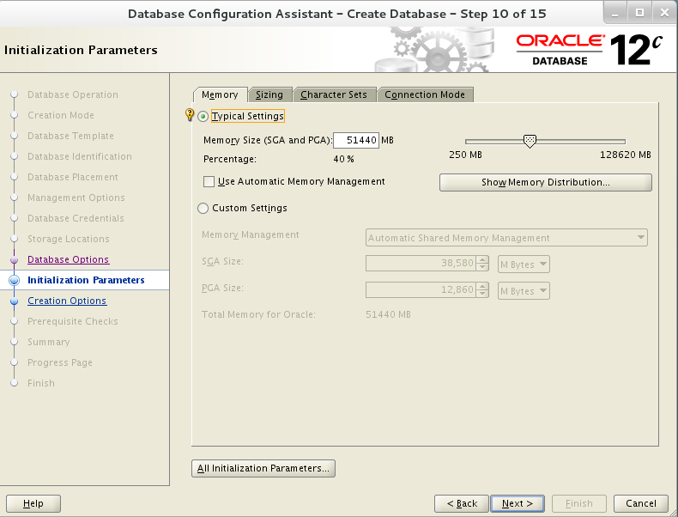

#### Sizeing

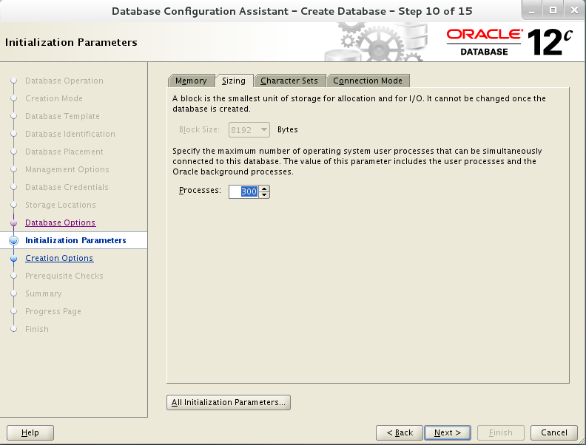

#### Character Sets

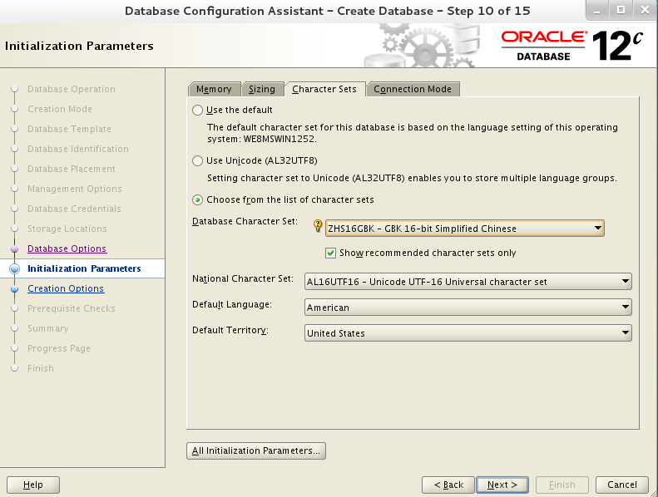

#### Connection Mode

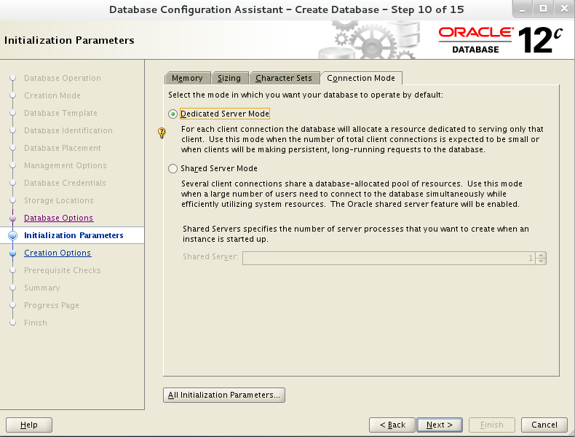

### 数据库创建选项

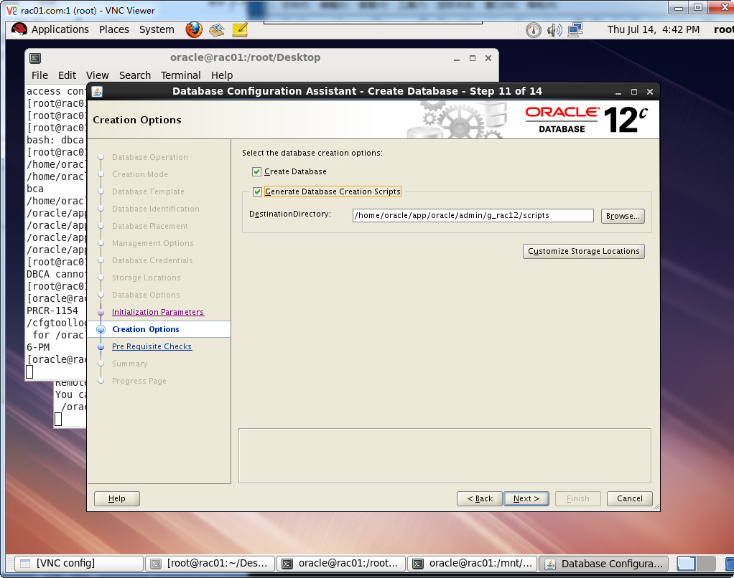

### 建库检查

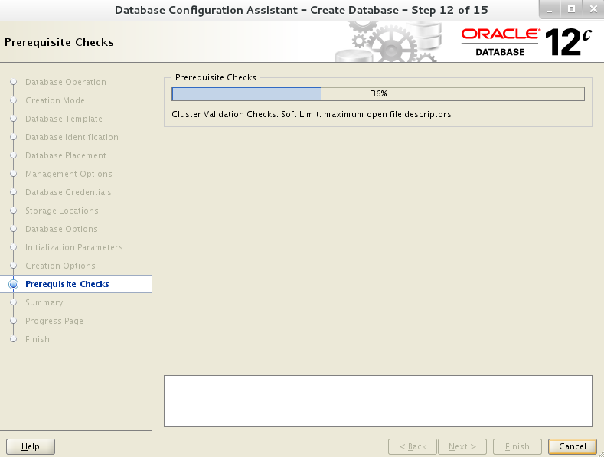

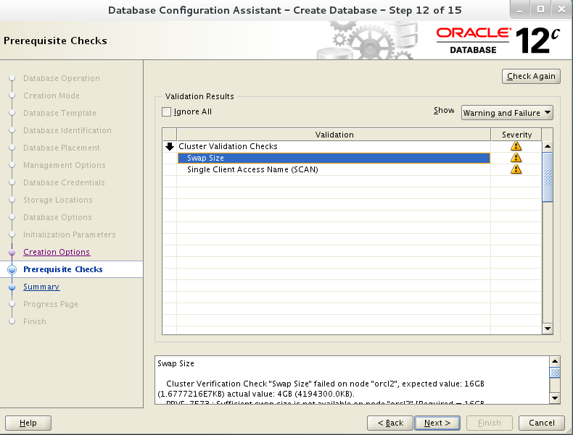

### 建库信息概要

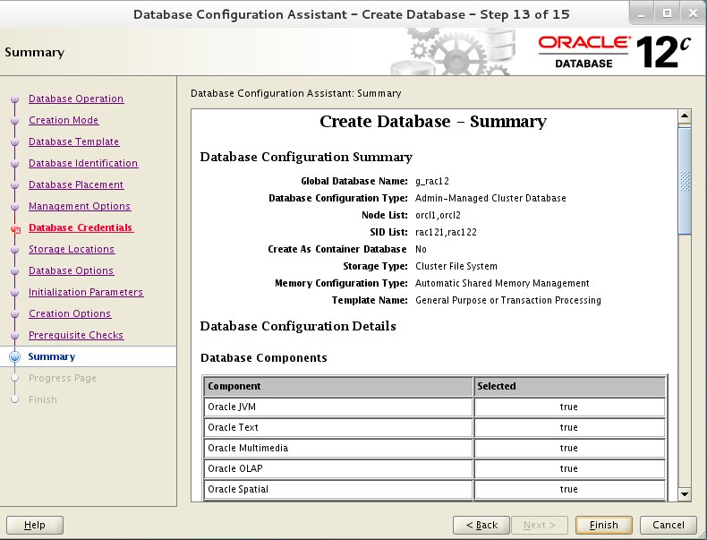

### 开始建库

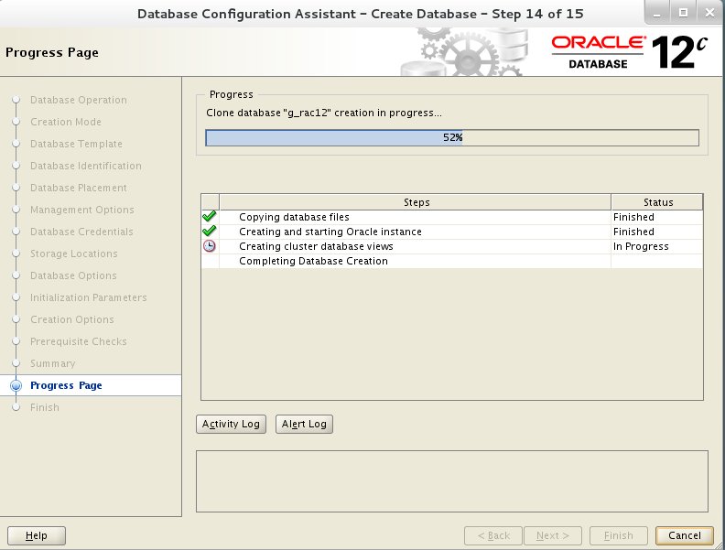

### 建库完成

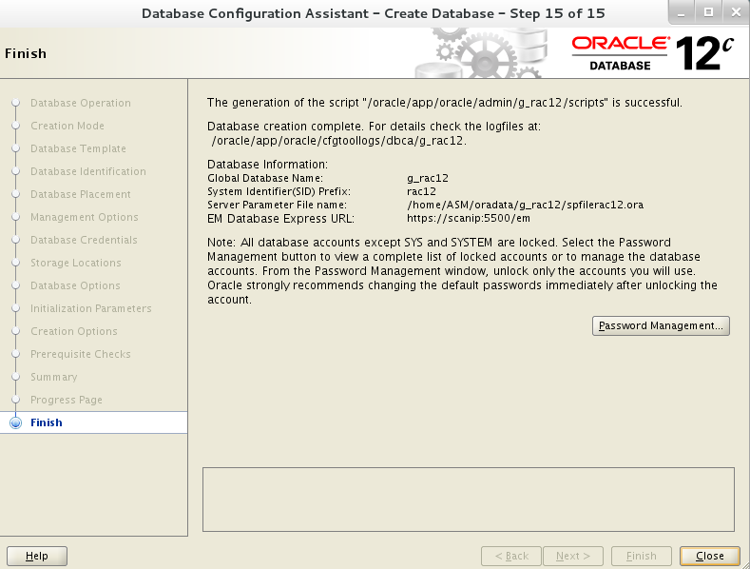

### Password Management

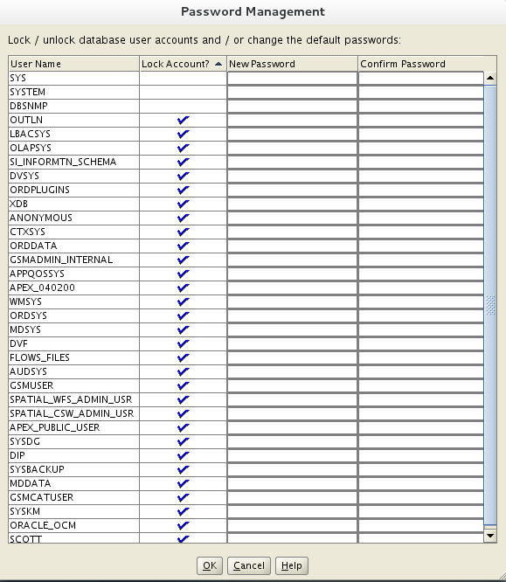

## 查看资源组情况

su - grid

#### Crs_stat -t

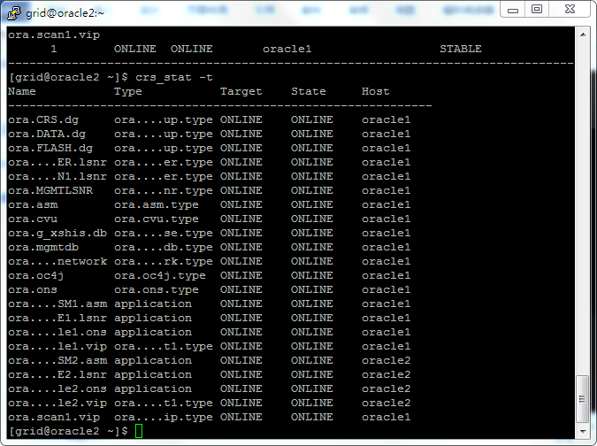

#### Crsctl status res -t

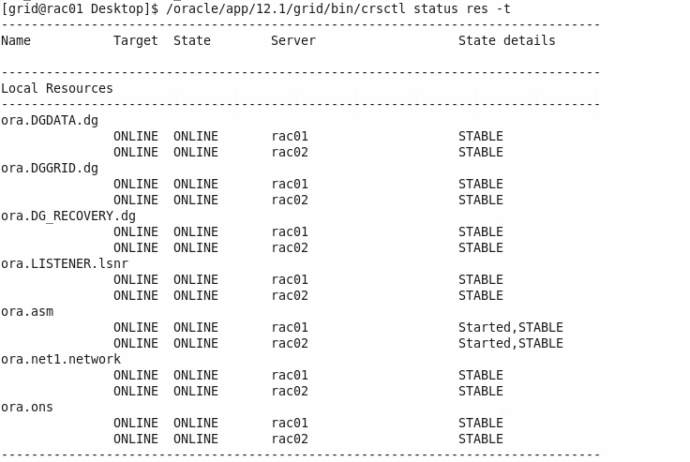

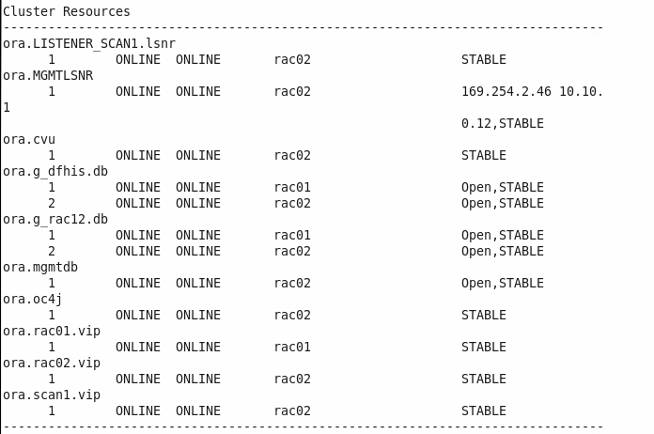

#### Servimce_name

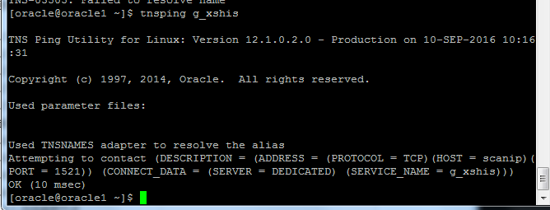

#### Listener

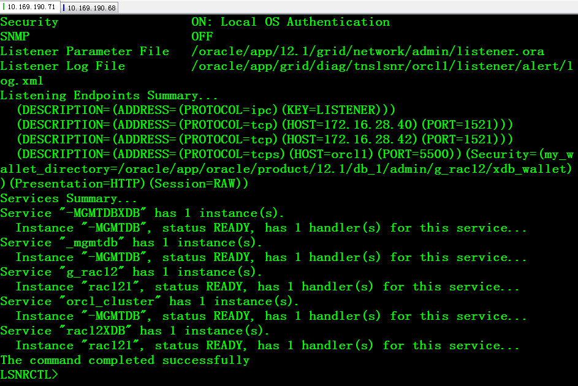

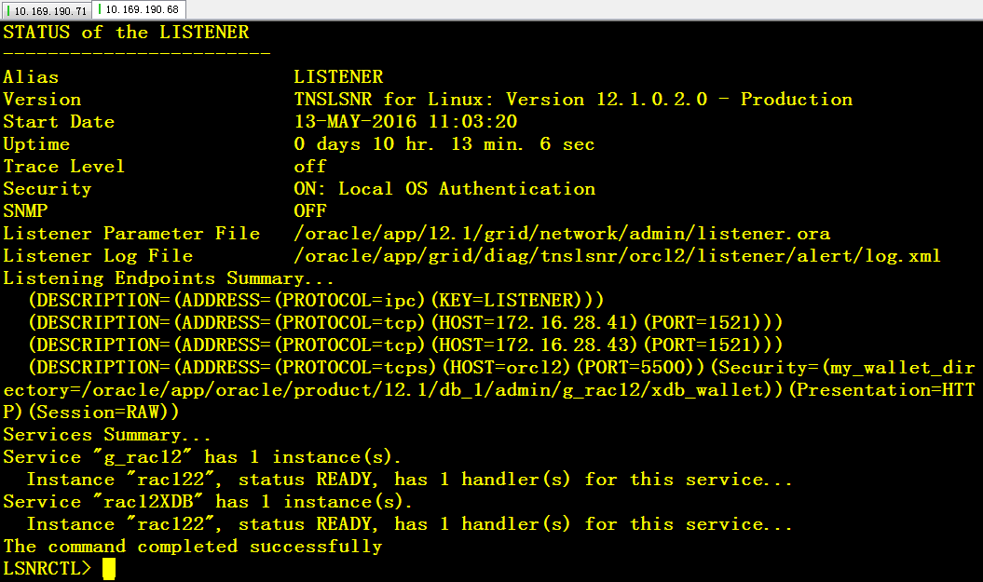

至此安装完成。